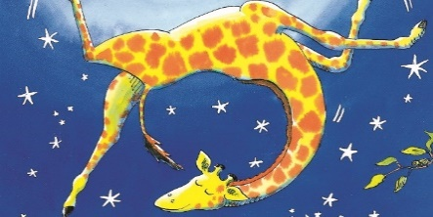
Monday, 8th February
LO: To use drama to retell a story and to describe how an animal may move!
Retell the story of ‘Giraffes Can’t Dance!’ Talk about the parts that you enjoyed and why! Then think carefully about three of the animals that you meet. Re-enact their dancing – draw them or take photographs and add them to the boxes! Using the verb sheet to help you, think of three words to describe how they danced and moved! They could have wiggled, jiggled, leaped or they might be busy, sluggish, crazy…
Animal One: __________________________

How they moved:

_______________________________________

_______________________________________

_______________________________________

Animal Two: __________________________

How they moved:

_______________________________________

_______________________________________

_______________________________________

Animal Three: _________________________

How they moved:

_______________________________________

_______________________________________

_______________________________________

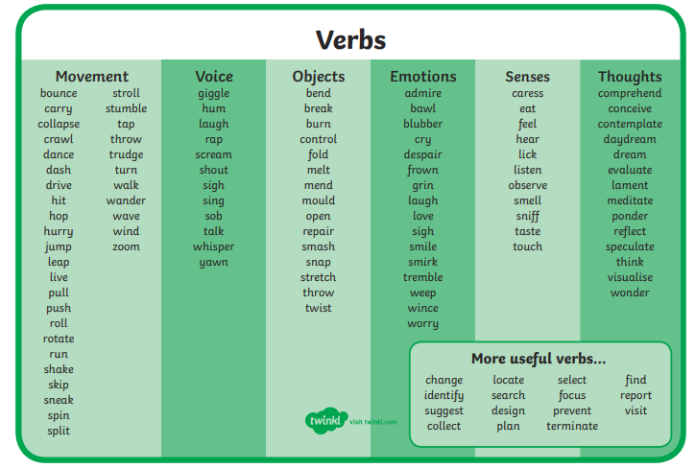
Tuesday, 9th February
LO: To sequence the story of ‘Giraffes Can’t Dance’ and to write simple sentences about what is happening in the different parts of the story
Cut out and stick the pictures in to the correct order. Choose at least three pictures to write a sentence about using capitals and full stops. Make sure you check it makes sense by reading aloud and that you’ve used finger spaces!
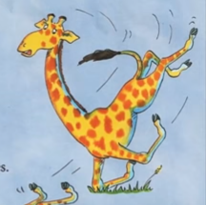 | 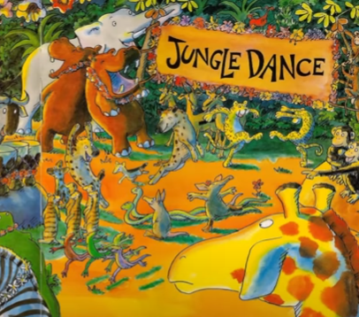
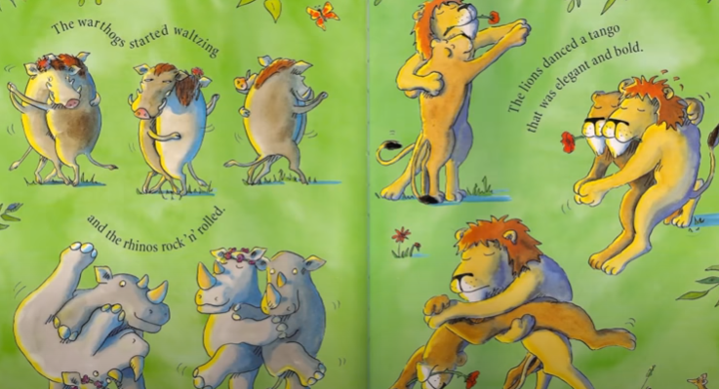 | 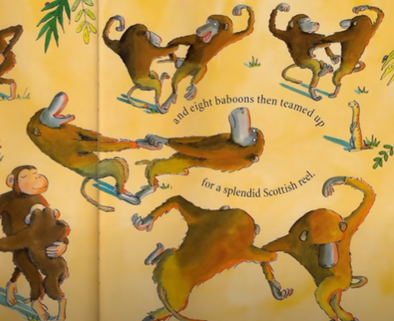
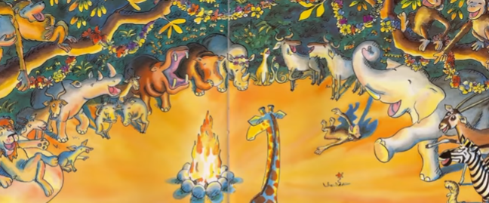 | 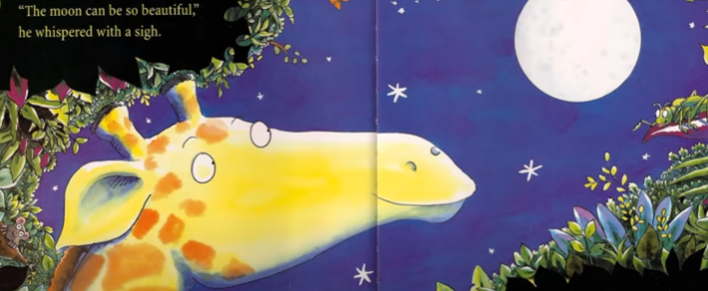
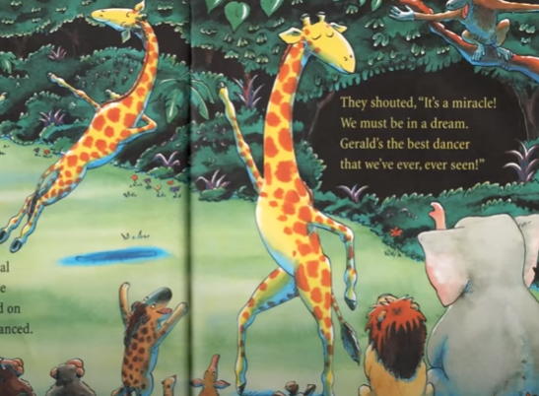 | 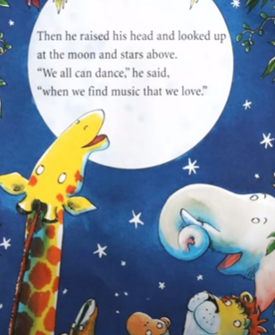
Wednesday, 10th February
LO: To unjumble sentences about ‘Giraffes Can’t Dance’ using my knowledge of punctuation to help me (capital letters and full stops)
Cut out the sentences below and re-order them so that they make sense! The capital letters, full stops and exclamation marks give you sneaky clues that will help you!
When you have glued them in to your book in order, choose three to re-write in your very best cursive writing. Remember to make tall letters tall and use tails for letters that need them.

a | Gerald | tall, | thin | giraffe. | was
ran | When | around | he | buckled | he
knees. | at | the
in | Every | Africa | they | held | year
dance. | the | jungle
danced | The | a | tango! | lions
all | The | did | a | cha-cha! | chimps

Thursday, 11th February
LO: To add missing punctuation
Rewrite the sentences below with the correct punctuation. You will need: capital letters, full stops, exclamation marks and question marks! Use your best cursive writing and check each one carefully.

- gerald had a long, thin neck
_________________________________________________
_________________________________________________
- every year they held the jungle dance
__________________________________________________
__________________________________________________
- giraffes can’t dance, you silly fool
__________________________________________________
__________________________________________________
4. how did you learn to dance like that
__________________________________________________
__________________________________________________
Draw a picture for your favourite sentence below!
Friday, 12th February
LO: To find and use adjectives
Adjectives add detail to our writing and make it more interesting. Read the sentences below and underline the adjectives. When you have found them, swap them! Think of different words you could use to describe and swap them in the sentences.

Gerald had a long, thin neck.

Gerald had a _________________________, ________________________ neck.

The hairy, grey warthogs waltzed.

The _______________________, _______________________ warthogs waltzed.

The clever, wiggly chimps danced.

The _______________________, _________________________ chimps danced.

The hippo had a huge, chubby body!

The hippo had a _________________________, ________________________ body!
Monday, 22nd February
LO: To think about what a character may be thinking or feeling in a story
Imagine what Gerald is thinking or saying during different parts of the story. He probably feels quite differently at the beginning and the end of the story. Using the pictures to help you, write down three things he may think or say. Write sentences using capitals, full stops, exclamation marks and if he asks a question, remember to use ? too!
________________________________

________________________________

________________________________
__________________________________________

__________________________________________

__________________________________________

___________________________________________

___________________________________________

___________________________________________

Tuesday,, 23rd February
LO: To use adjectives to describe what Gerald from ‘Giraffes Can’t Dance’ looks like and what his character is like
Add labels to describe how Gerald looks – you do not need capital letters or full stops as they are not full sentences. Try to use two adjectives together, with a comma between them if you can! (For example, ‘long, slim neck’, ‘large, brown spots’)

________________________________
________________________________
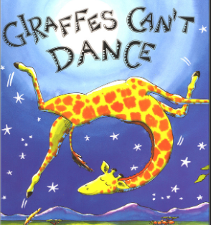
__________________________ _______________________________
_______________________________

__________________________
__________________________ _________________________
__________________________ _________________________
_________________________

Now think of two sentences to describe what he is like as a character. Is he kind? Cruel? Funny? Cheerful? Use ‘because’ to explain why you think that.
For example, Gerald is brave because he carries on, even when they are cruel to him. Use the word mats to help you.

__________________________________________________________________________________

__________________________________________________________________________________

__________________________________________________________________________________

__________________________________________________________________________________
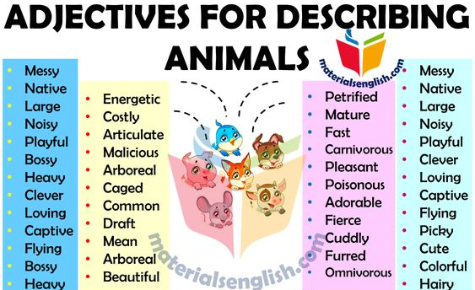
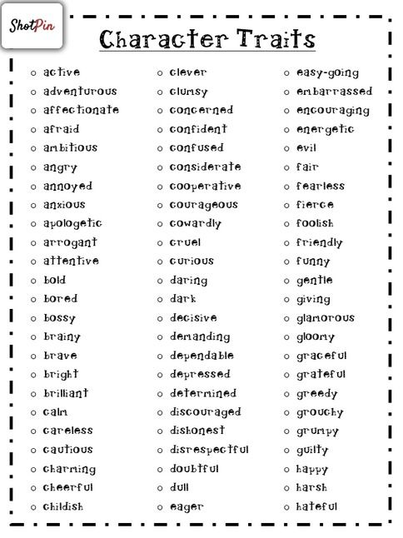
Wednesday,, 24th February
LO: To consider the emotions of a character
Gerald is feeling very sad and upset during different parts of the story. What would you do to cheer him up? Tell me in a few sentences and draw a picture of you and Gerald having a wonderful, cheery time!

________________________________________________________________________________________________________________________________

________________________________________________________________________________________________________________________________

________________________________________________________________________________________________________________________________

________________________________________________________________________________________________________________________________

________________________________________________________________________________________________________________________________

Success Criteria 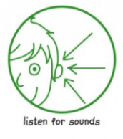
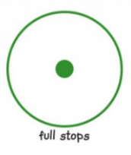
Bronze Success Criteria – supported by an adult to scribe and write | Child | Adult
Have I used simple (single) adjectives to describe what my character looks like?
Have I used simple (single) adjectives to show what Gerald felt like or was like during one part of the story?
Have I used full stops at the end of my sentences?
Have I used finger spaces between words?

Silver Success Criteria – supported by an adult to form ideas and write sentence by sentence | Child | Adult
Have I used adjectives to describe what my character looks like?
Have I used my senses to help show what Gerald felt like during the story and described his character?
Have I used full stops at the end of my sentences?
Have I formed my letters correctly using lead-in and lead-outs?
Have I re-read my work to check that it makes sense? (Edit with an adult)

Gold Success Criteria – supported by an adult to share ideas then attempt to write with some independence | Child | Adult
Have I used two adjectives to describe what my character looks like and what he is like with a comma in between?
Have I used my senses to help show what Gerald felt like during different parts of the story? (try to ‘show’ how he feels rather than saying ‘he is happy’ he could be ’smiling from ear to ear’)
Have I used full stops to show the end of my sentences?
Have I formed my letters correctly using lead-in and lead-outs?
Have I read my own work to check that it makes sense? (Edit independently)

Thursday, 25th and Friday, 26th February
LO: To write a character description for Gerald from ‘Giraffes Can’t Dance’
Write a character description for Gerald who wants nothing more than to dance. You could choose to write about Gerald at the beginning of the story or at any other point. Use the guidance below to help you and remember to include sentences about what he looks like and what he is like.
Title
Make sure you think carefully about who you are writing about –a title helps you to do this!
Paragraph One
Tell me what Gerald actually LOOKS like. Describe what you see when you look at him: his face, body, legs…
Paragraph Two
Tell me what Gerald actually IS like. Is he kind, scary, gentle, noisy, smart, friendly, afraid…? (He feels differently during the story).
Adjectives
Your description needs to use adjectives (describing words) to make it interesting for the reader. Try to use two together with a comma in between. Instead of writing,
‘Gerald has a neck’ you could say ‘Gerald has a long, slim neck that stretches to the sky’ which is much more interesting! You can use the ones from the story too!
Senses
Use your senses to make your writing more exciting – what can he see, hear, touch? Try to show me how he feels – ‘He danced with joy’ rather than ‘He was happy’.
Punctuation and Sense
Remember to use capitals for names and to start your sentences. Use commas between two adjectives. Use full stops to end your sentences and to show the reader where to pause, giving your writing meaning. Always read your work aloud to check it makes sense!
Gerald the Giraffe
Gerald the giraffe had a tall, brown body and long, slim legs. He had small, black circles for eyes and pointed, yellow ears! His knees were very knobbly and they wobbled when he walked on his crooked, thin legs. His furry neck stretched up to the sky and he used this to help him eat fresh, green leaves from the tall trees.
Gerald loved to dance. He could hear music wherever he went and he loved to look at the shining, white moon in the dark, night sky. Tears rolled down his cheeks when the animals teased him for not being able to skip and prance. He danced to the swaying grass and smiled when he saw branches moving in the breeze. The other animals became quite entranced with his wonderful, energetic dancing!
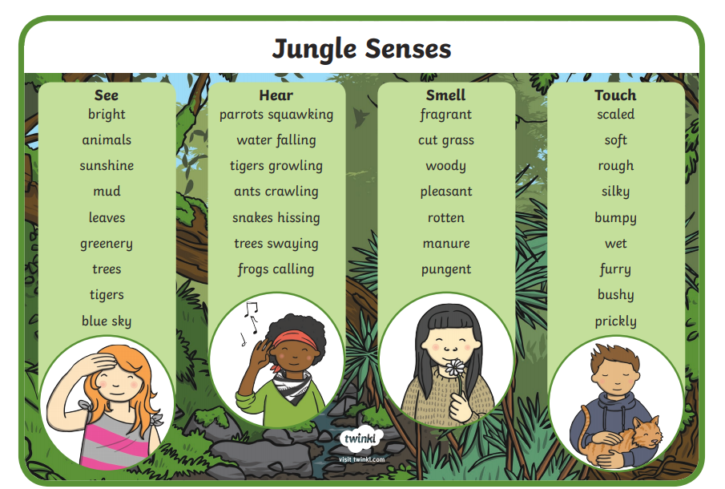
Thursday, 25th and Friday, 26th February
Gerald the Giraffe

__________________________________________________________________________
__________________________________________________________________________
__________________________________________________________________________
__________________________________________________________________________
__________________________________________________________________________
__________________________________________________________________________
__________________________________________________________________________
__________________________________________________________________________
__________________________________________________________________________
__________________________________________________________________________
__________________________________________________________________________
__________________________________________________________________________
__________________________________________________________________________
__________________________________________________________________________
__________________________________________________________________________
__________________________________________________________________________
__________________________________________________________________________

