Monday 8th February- L/PD/CL  When I grow up…  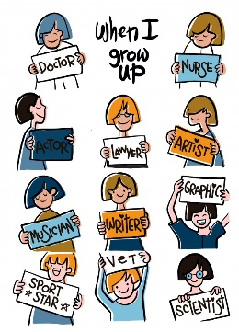  Talk about all of the different people who help us. There are lots! Draw a picture to show what you would like to do for a job when you grow up. What would you have to wear? Would you need any special tools/equipment? A special vehicle maybe?  Try labelling your picture. | Tuesday 9th February  PE  Cracker The Dragon Of Wonder | A Cosmic Kids Yoga Adventure! - YouTube  Music  Practise your dancing skills – can you make up your own dance?  Preschool Learn to Dance: Banana Boogie - YouTube |  | Wednesday 10th February  UtW/CL/PD  Explore the videos all about the Chinese New Year..  https://www.bbc.co.uk/cbeebies/watch/chinese-new-year  Use your cutting skills to create a Chinese lantern. Follow the instructions in your home learning pack. You could use glitter/sequins to decorate your lantern. |  | Thursday 11th February  PSE/EAD  Share the powerpoint about Valentine’s day. It is all about people who are special to us, that we love.  Create a love heart themed item – you can choose how you would like to do this. You could thread, collage, paint, colour, handprint, bake, mould! Be as creative as you can and then think of somebody you love that you could give your heart to.
Friday 12th February M Shrove Tuesday  Pancake flipping! Make a pancake out of card or cardboard. Put it in a pan and see how many times you can flip it without dropping it on the floor! How many flips can you get in 30 seconds? |  | Monday 22nd February UtW/CL/EAD  On the Farm – Old McDonald  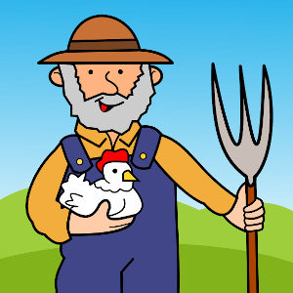  Sing Old Mcdonald – think of as many different farm animals as you can – can you make each noise that the animal makes. Choose one of the animals and make your own farm animal mask! |  | Tuesday 23rd February  PE  Farm Animal Exercise | Indoor Workout for Children | No Equipment Needed PE Lesson for Kids - YouTube  Music  Join in with Mr Hall’s music lessons  Music Time 1 - YouTube
Wednesday 24th February M  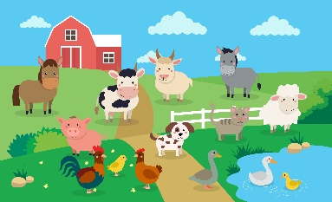  Look at the farm picture (in your home learning pack) Count each animal carefully using 1:1 touch counting, when you have counted have a go at writing the number in the box. |  | Thursday 25th February L/CL  Guess the farm animal game. Have a selection of toy farm animals or pictures in a box.. Give clues to your child about the animal, you could include words that it rhymes with, the initial sound of the animal, if they haven’t got the answer you could segment the answer and encourage them to blend! |  | Friday 26th February PSE  Read the story ‘Odd Jobs’ from in your home learning pack. Answer the questions and talk about the jobs that you do at home. Could you think of any other jobs you would like to do at home to help your mummy and daddy?`

In addition to the activities on the grid we will be completing a 10 minute daily meditation session after lunch – videos can be found for this by searching ‘children’s meditation’ on you tube. There are lots of different ones to choose from!
We will also be completing daily name writing – it would be great if you could do this at home too. Please try to encourage your child to use cursive handwriting using lead ins and lead outs.

Thank you for your support!

