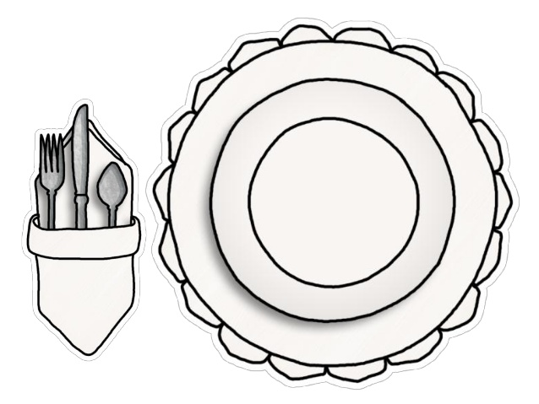

Book title:_________________________________________________________

Genre: __________________________________

What are your first impressions of the book based on the front cover and blurb?

____________________________________________________________________________________________________________________________________________________________________________________________________________________________________________________________________________

After reading a few pages, what do you think of the book so far? Do you want to read on? Why?

____________________________________________________________________________________________________________________________________________________________________________________________________________________________________________________________________________

Which character(s) have you met already? Describe them?

____________________________________________________________________________________________________________________________________________________________________________________________________________________________________________________________________________

What did the author do to hook or interest you in the book?

____________________________________________________________________________________________________________________________________________________________________________________________________________________________________________________________________________

Who would you recommend this book to and why?

____________________________________________________________________________________________________________________________________________________________________________________________________________________________________________________________________________

Rating: ____/10

**Name:________________________________**

Hillside Primary

Book Tasting 2021