Maths Home Learning Grid - Nursery
Book Week W.C 1.3.21
This week’s activities embed many of the skills the children have been learning since January. Repeating these activities in different ways helps the children to develop their understanding and apply what they have learned.

Monday 1st March  Have a go at some underwater counting – you can choose counting to 5 or counting to 10, remember to do very careful counting!  https://www.topmarks.co.uk/learning-to-count/underwater-counting | Tuesday 2nd March  Use the cards provided (in your home learning pack) count the sea life pictures on each card and circle the correct number to show how many are on the card. Can you show the correct amount of fingers too? |  | Wednesday 3rd March  Complete the I Spy and count activity (in your home learning pack). You need to make sure you do some very good searching here so that you don’t miss any of the sea creatures! Practise writing your answers in the boxes – you can use your number line to help you.
Thursday 4th March  Sing 1,2,3,4,5 Once I Caught a Fish alive – whilst singing can you show the right amount of fingers? Start off singing slowly and gradually get faster. When you have repeated it a few times – see if you can show the right amount of fingers when the numbers are said out of order, ask your grown up to challenge you!  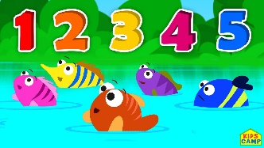 |  | Friday 5th March  Thinking about all of the different colours of sea creatures underwater, can you collect a selection of objects from in your house and sort them into colours. Can you use all of these colourful objects to make a sea creature?  