Maths Home Learning Grid - Reception –
W.C 1.3.21
Monday 1st March  Click on the link below to access Session 1 Maths video. Representing and sorting 9 and 10.  https://whiterosemaths.com/homelearning/early-years/building-9-10-week-1/  Explore how many different ways you can make 9 Then see how many different ways you can make 10  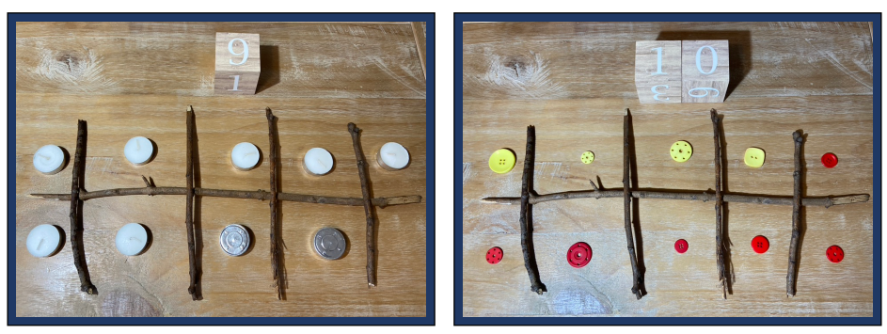  What do you notice?  Can you spot numerals 9 and 10 in the environment?  Digging Deeper- Can you think of some corresponding subtraction facts that make 9 and 10? | Tuesday 2nd March  Click on the link below to access Session 2 Maths video. Representing and sorting 9 and 10.  https://whiterosemaths.com/homelearning/early-years/building-9-10-week-1/  Have a look at each card. Does it represent 9 or 10? Sort the cards into two groups.  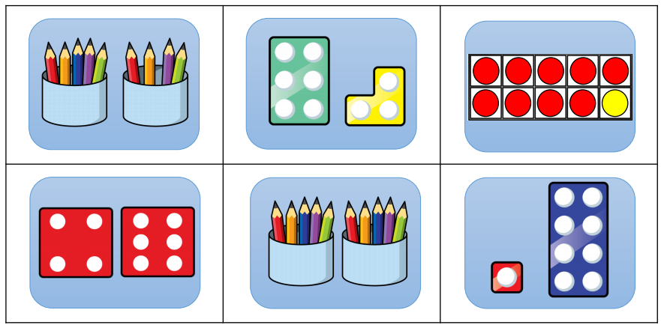  Now make your own cards to represent 9 and 10 Have a go at sorting these cards too.  Digging Deeper- Can you think of an addition number problem that has the answer 9 or 10?  E.g. If I had 9 pencils and my friend gave me one more. How many would I have? | Wednesday 3rd March  Click on the link below to access Session 3 Maths video. Ordering numerals to 10.  https://whiterosemaths.com/homelearning/early-years/building-9-10-week-1/  Order numerals 1-10 Ask a helper to change something on your number line. Can you spot the mistake and correct it?  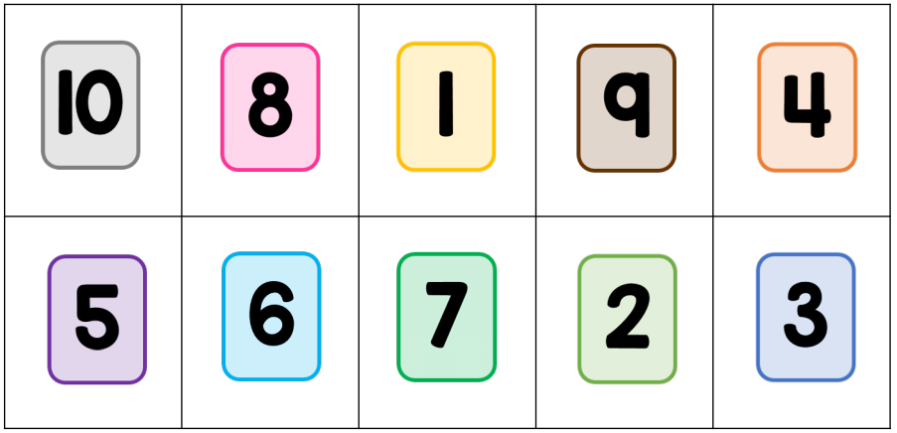  Digging Deeper-Can you order just 5 random numbers, that your parent chooses? E.g. 2, 7, 9, 3. Practise using a variety of combinations.
Thursday 4th March  Click on the link below to access Session 4 Maths video. Composition of 9 and 10.  https://whiterosemaths.com/homelearning/early-years/building-9-10-week-1/  Here is Teddy's black dots number 9 picture. Draw your own number 10 picture using 10 black dots. Then have a go at drawing another picture, exploring the different ways you can show 10.  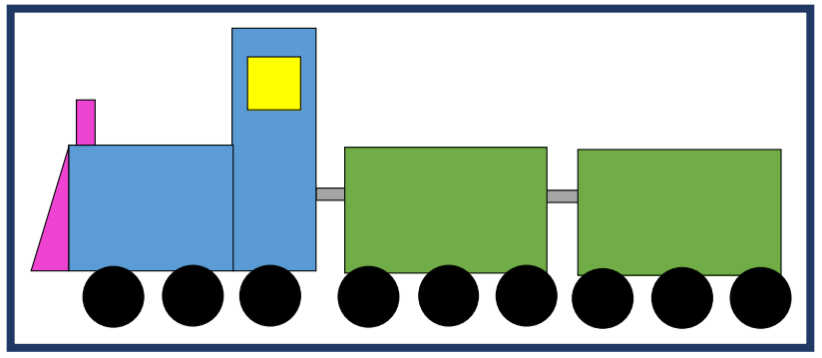  Digging Deeper-Think of a subtraction number problem that makes 10. | Friday 5th March  Click on the link below to access Session 5 Maths video. Numbers to 10 Bingo  https://whiterosemaths.com/homelearning/early-years/building-9-10-week-1/  Play your own game of bingo. You could make your own bingo cards by adding your own numerals and/or using picture cards.  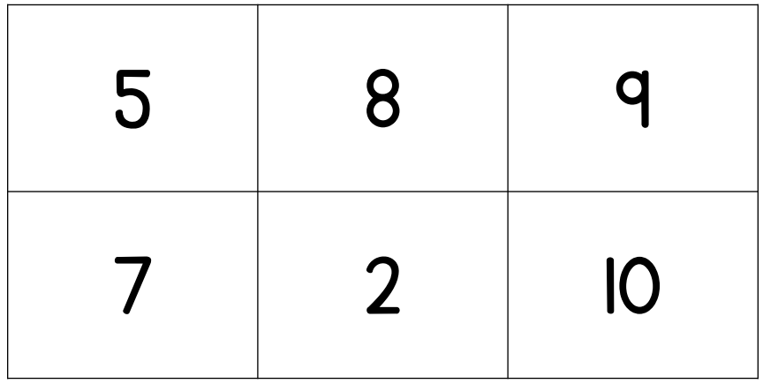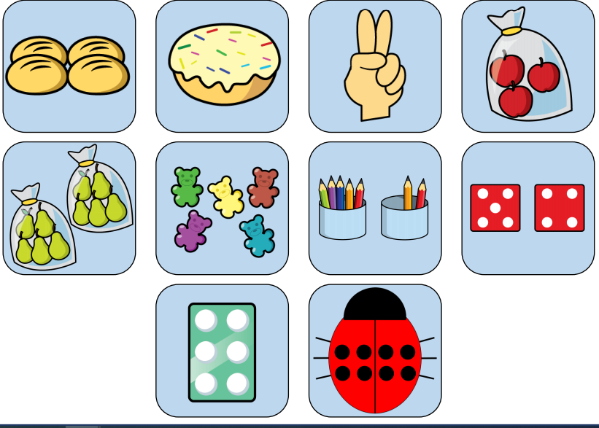  Digging Deeper- Think of your own number problems to equal the numbers on your bingo card. E.g 1 more than 4 = 5 | Counting  Practise counting in 1’s, 2’s and 10’s.  There are lots of songs to help you. Here are a few.  Counting in 1’s  https://www.youtube.com/watch?v=INyHLYfasTU  Counting in 2’s  https://www.youtube.com/watch?v=GvTcpfSnOMQ  Counting in 10’s  https://www.youtube.com/watch?v=-gmEe0-_ex8

Digging Deeper – These are ways of extending your child’s learning even more.

