Reading - Daily  Log on to Purple Mash and read a chapter a day, there are seven chapters all together.  Complete the comprehension questions for each chapter and some of the optional activities.  Once you have read the book, complete the book review so I can see what you thought of it. | 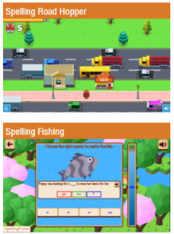  Spelling Frame - Daily  Practise this week’s spelling rule, words containing the ‘s’ sound spelt as sc. These words originate from the Latin language!  Choose different games to play to practise the spellings of these words. | Times Tables Rock Stars - Daily  Play on Times Tables Rock Stars for at least ten minutes per day.  I might even set a rock off next week between the boys and the girls!!  Remember to log on and play to win points for your band!  I’ll be looking to see who has been practising!

Hillside Primary School Home Learning Grid 3 - Year 4
Science 1 – Thursday 11th February  Have a look at the lesson link below, explaining about freezing and melting  Don’t forget to press ‘narration’ to hear the lesson being taught, then complete science sheets 1 from the topic resource sheets. | Science 2 – Thursday 25th February  Use the second lesson link below to learn about the first lesson in our new topic ‘The human body’.  Use the ‘narration’ button to listen to the lesson.  Now complete Science sheet 2 from the topic resource sheets. | Handwriting – twice a week  Keep improving your cursive handwriting. Copy out the poems from the resource sheets.  Make sure your work hard on your target areas. What is it you need to improve? Size? Joins? Specific letters? Let’s be ready for more pen licences when we get back to school! | Computing - ongoing  I have set some more activities on Purple Mash. Have a look at using your computing skills to complete your 2Do’s!  Don’t forget to take your time when completing your work and leave me a message when handing in your work!
8.2.21 – 26.2.21 - Core Subjects

Science 1 link: https://developingexperts.com/s/missions/1392?slide=1&noExit=false&presentation=1392
Science 2 link: https://developingexperts.com/s/missions/155?slide=1&noExit=false&presentation=155

Hillside Primary School Home Learning Grid 3 - Year 4
8.2.21 – 26.2.21 - Foundation subjects
Geography – Monday 8th February  Watch the following two video clips to learn about climate and biomes.  https://www.bbc.co.uk/bitesize/articles/zhpsxbk  Now, using the resource sheets below, look at the maps and use the keys to complete the questions about climate and biomes around the world. | French – Tuesday 9th February  Using the work you completed last time, researching and finding out the French words for different food and drinks, use this knowledge to complete the word search.  There may be some words you didn’t find out, so you will have to translate them first before finding them.  Then, on the next resource sheet, sort the foods into one you like and don’t like. As an extra challenge, add some more to each set. | PE – Wednesdays  Keep yourselves active while in lockdown.  Use the Time for Sport activities using this link.  https://www.time4sportuk.com/client-area/s/hWE3SjypOawkmnt  or go on a bike ride, a walk, have a go at joining in with a Joe Wicks session or try some yoga.  cosmic kids yoga ks2 - Bing video | PSHE – Friday 12th February  This week we are looking at emotions, the way we feel and express ourselves. We react in different ways when we experience different emotions. Sometimes we can show extreme emotions to quite small events, this is called ‘over-reacting’. Look at the degree of emotion sheet (PSHE resource sheet) and order each group of emotions from mild to extreme emotions.  Then choose one emotion from each column and think of a situation where this emotion would be a sensible reaction.
DT/computing –  Monday 22nd February  We are going to be looking at a new program on Purple Mash called 2design and make. This is where we can use computer aided design (CAD) to design and make models on the computer to create 3d products.  Have a look at your 2do and listen to my instructions to create a product. | Art - Tuesday 23rd February  Onemone Hammersley creates many pieces of rainforest art. You are going to look at her work in more detail and ANALYSE her style and her work. Look carefully at the four pieces of her art work on the resource sheets and answer the questions about them on the other sheet. Try to think carefully about her style and what makes her a successful artist. | Music – Wednesdays  Mr Hall has put together six weeks worth of lessons specifically for Year 4. Follow the link below to access these, one per week.  https://jamsinging.wordpress.com/y4-musical-activities/ | RE – Friday 26th February  Have a look at the poster on the RE resource page showing you the Golden Rule in many religions? What is the main message that the Golden Rule is about? All religions follow this rule to live a good life for themselves and others. Using ideas from the different religions, either write your own Golden Rule or choose your favourite one from the poster and create a poster to display your Golden Rule. Use words, illustrations and colour.

Geography – Monday 8th February
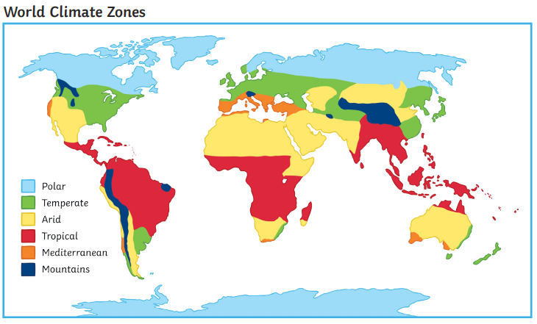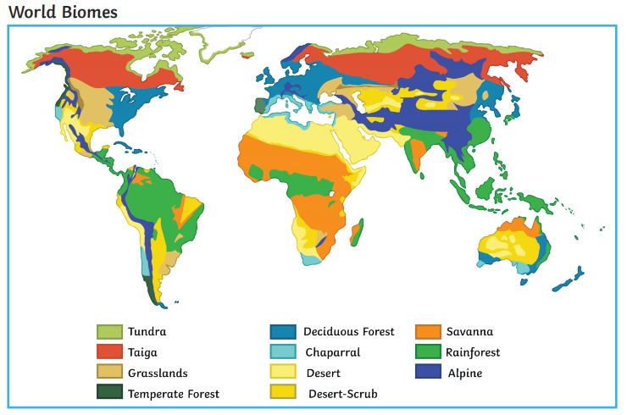
Geography – Monday 8th February
Using the two world maps on the previous resource sheet, showing world climate zones and world biomes, use your world map skills and knowledge to complete the questions on this sheet.
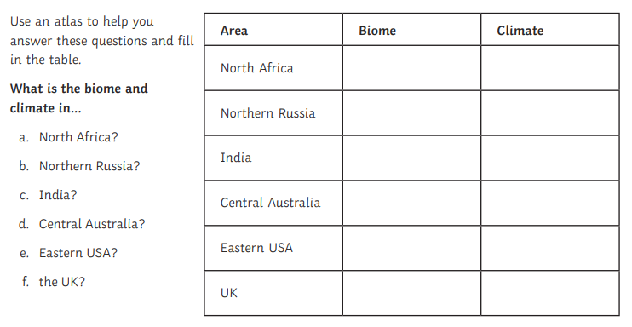

French – Tuesday 9th February
Using your research from last time on food and drinks, find the FRENCH word for each of these in the word search.

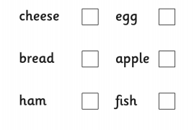
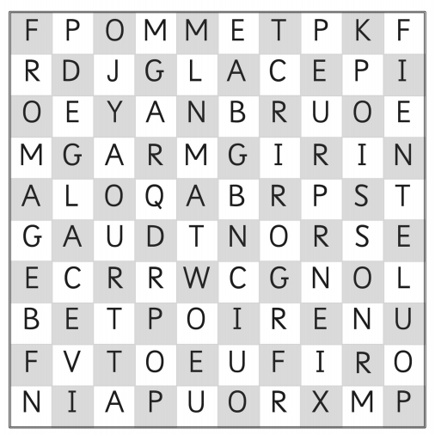

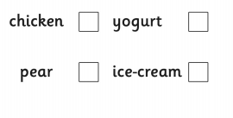

French – Tuesday 9th February
Sort the food into ones that you like (J’aime) and the ones you don’t like (Je n’aime pas). Can you add more to each set?
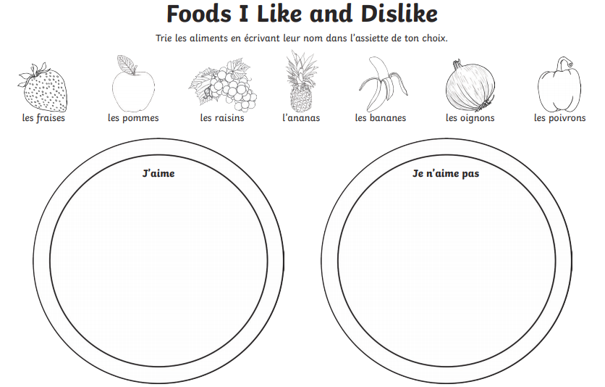
PSHE – Friday 12th February
Look at the three column: happiness, sadness and anger. Order the emotions in each column from 1 – 5. 1 showing the mildest emotion to 5 being the most extreme and strongest emotion.
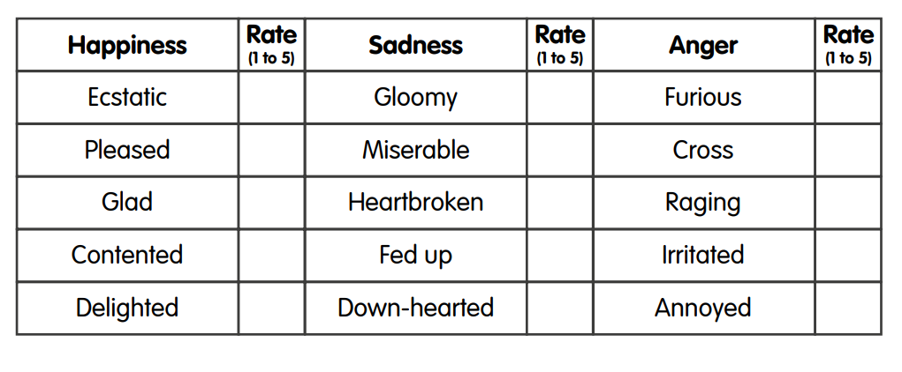
Now choose one emotion from each column and think of a situation where you would expect to see this emotion. These might be examples of when you have felt this particular emotion or seen others display this emotion Record your ideas below:
Happiness  Chosen emotion - ____________________  A time when I would see/feel this emotion _____________________________  _____________________________________  _____________________________________  _____________________________________  _____________________________________  _____________________________________  _____________________________________ | Sadness  Chosen emotion - ____________________  A time when I would see/feel this emotion _____________________________  _____________________________________  _____________________________________  _____________________________________  _____________________________________  _____________________________________  _____________________________________ | Anger  Chosen emotion - ____________________  A time when I would see/feel this emotion _____________________________  _____________________________________  _____________________________________  _____________________________________  _____________________________________  _____________________________________  _____________________________________
Tuesday 23rd February – Art
Have a look at the pieces of rainforest art work by Onemone Hammersley on the next pages. You are going to look closely and analyse them.
What do you notice/what do you see when looking at her style of artwork? Think about the colours, shapes and patterns used. What is similar and what is different between the pieces?
____________________________________________________________________________________________________________________________________________________________________________________________________________________________________________________________________________________________________________________________________________________________________________________________________________
Looking at the style of Onomoe Hammersley, which features of her work do you like the most?
I like that way that she ______________________________________________________________________________________________________________________________________________________________________________________________________
Looking at the style of Onomoe Hammersley, which features of her work do you like the least?
I don’t like that way that she ______________________________________________________________________________________________________________________________________________________________________________________________________
Which piece of Oemone Hammersley’s is your favourite and why?
_________________________________________________________________________________________________________________________________________________________________________________________________________________________________________________________________________________________________________

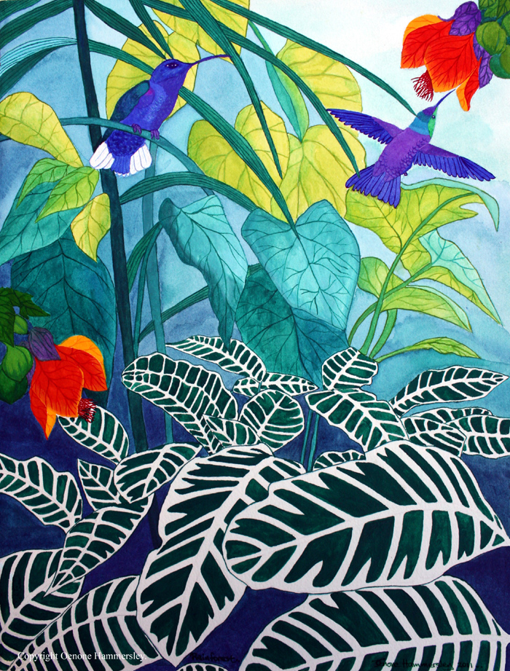
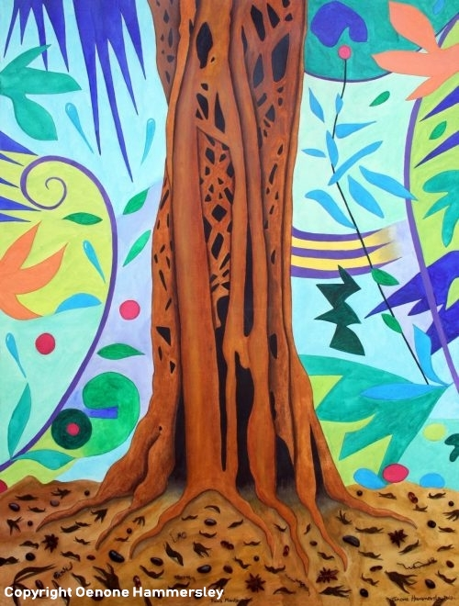
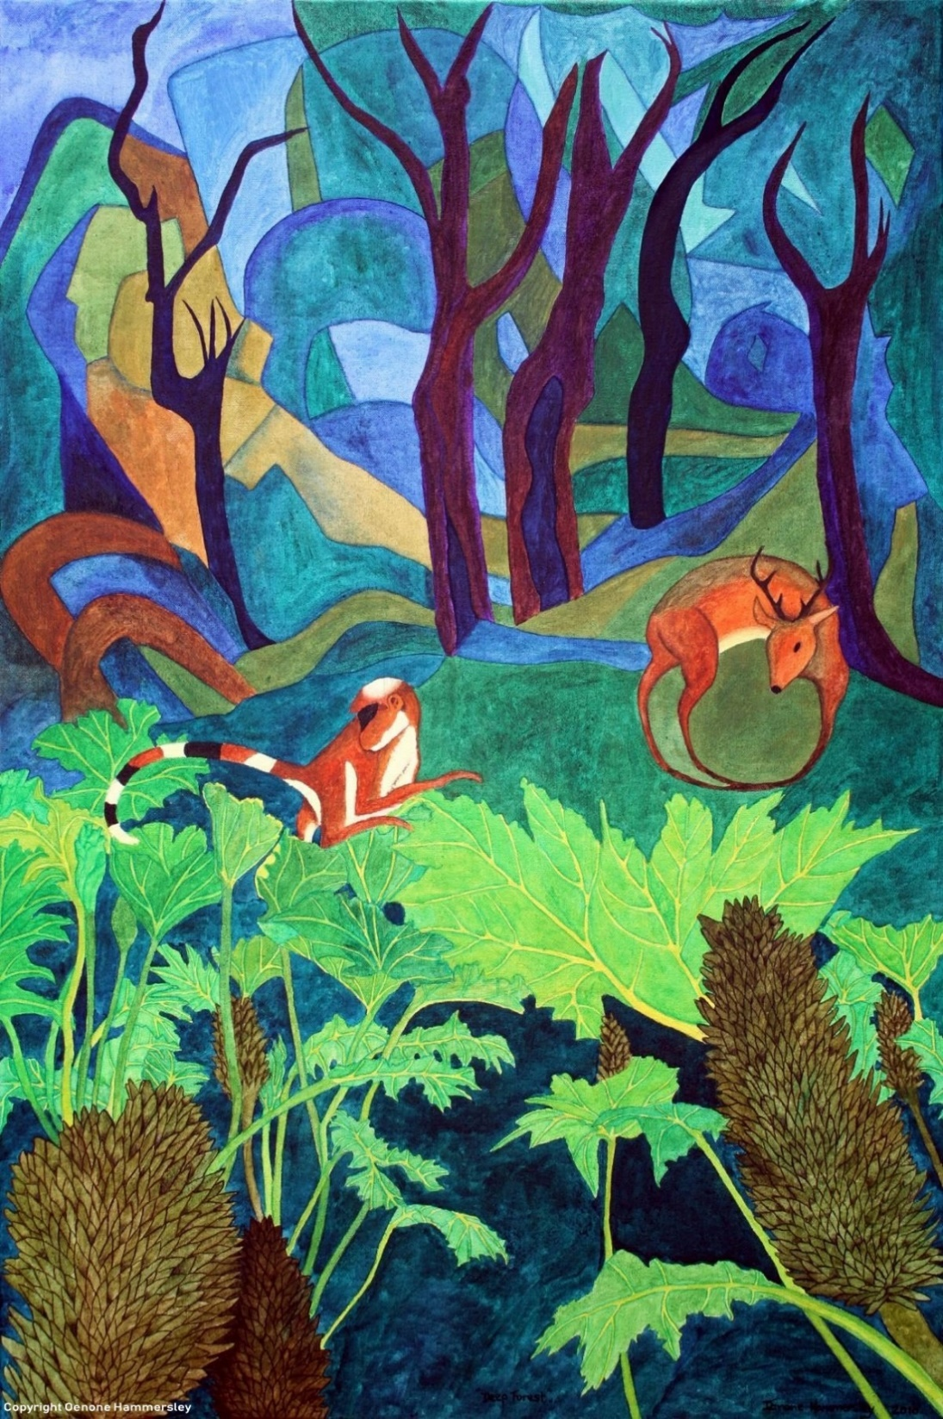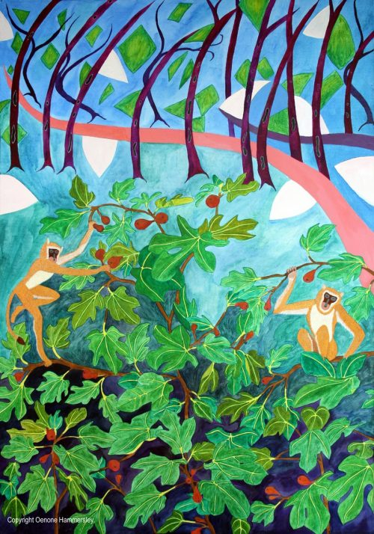
Friday 26th February – RE
Look at the information poster about ‘The Golden Rule’, a rule followed by many religions. What is the message about? Now create a poster to display EITHER your own worded Golden Rule OR choose one from below to illustrate and display as a poster.
