Resource sheet 1 – Mon 8.2.21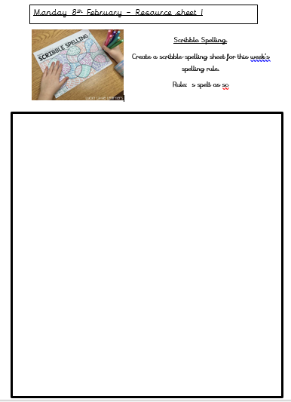

Resource Sheet 2 – Mon 8.2.21

LO: To understand and spell ‘s’ phoneme as ‘sc’.

Match each word to its definition

|  |  |
| --- | --- |
| Word | Definition |
| discipline | The aroma coming from someone or something that is usually pleasant |
| crescent | A person who is studying or has expert knowledge of biology, chemistry or physics |
| scent | An instrument used for cutting paper, cloth and other thin materials, which consists of two metal blades. |
| scientist | A climb or walk up a hill or mountain |
| scissors | A curved 2D shape |
| ascent | To train someone to behave appropriately. |

Apply Choose from the words above to complete these sentences.

1. I saw a bright _________________________ moon in the sky last night.
2. If Miss McCann wasn’t a teacher, she would probably be a ________________________.
3. The school had to bring in stricter _____________________________ after lockdown as some children had forgotten how to behave!

4.The roses gave of a beautiful ______________________________, which filled the room.

5. On my adventure, I made my _________________________ up to the top of Mount Everest.

6. To make my 3d rain forest model, I had to use ______________________ to cut the leaves out properly.

Resource sheet 3 – complete any day

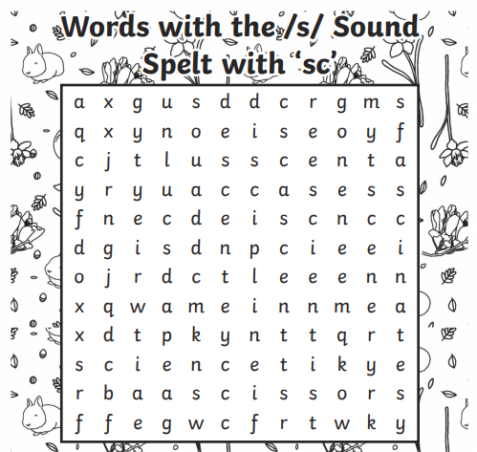

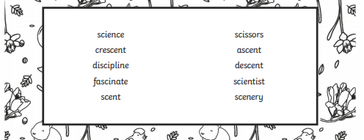

Resource sheet 4 – complete any day

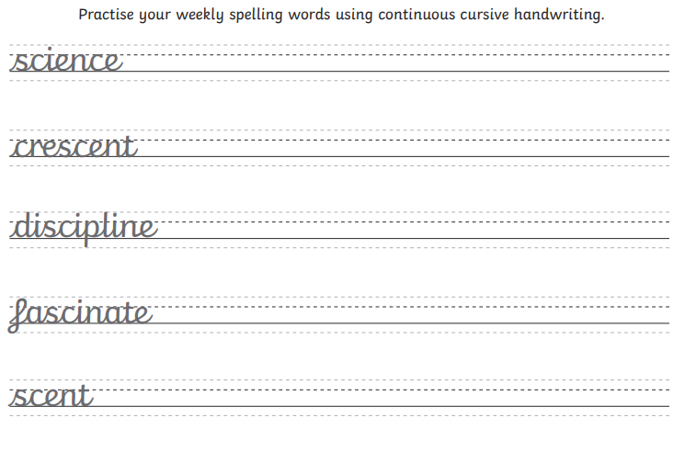

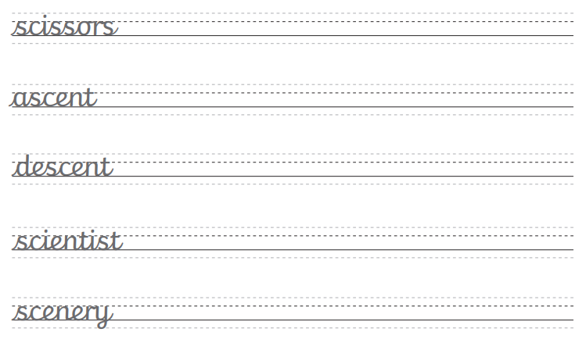

Resource sheet 5 – Tues 9.2.21

1. Where do you think the story is set? Why do you think this?

________________________________________________________________________________________

________________________________________________________________________________________

________________________________________________________________________________________

1. Why do you think the boy is camping on his own?

Give more than one reason

________________________________________________________________________________________

________________________________________________________________________________________

________________________________________________________________________________________

1. What causes the monster’s attitude to change at 1m 17s into the film?

________________________________________________________________________________________

________________________________________________________________________________________

________________________________________________________________________________________

1. Where do you think the boys is running to at the end of the film?

________________________________________________________________________________________

________________________________________________________________________________________

________________________________________________________________________________________

1. Now that you have watched the film, what would you do if you met that monster?

____________________________________________________________________________________________

____________________________________________________________________________________________

____________________________________________________________________________________________

____________________________________________________________________________________________

Resource sheet 6 – Wed 10.2.21

Read the paragraph on resource sheet 7 and hunt for the nouns, adjectives, verbs, adverbs and prepositions. Draw a coloured line under each type of word and create a key to show the different word classes.

Here’s some reminders:

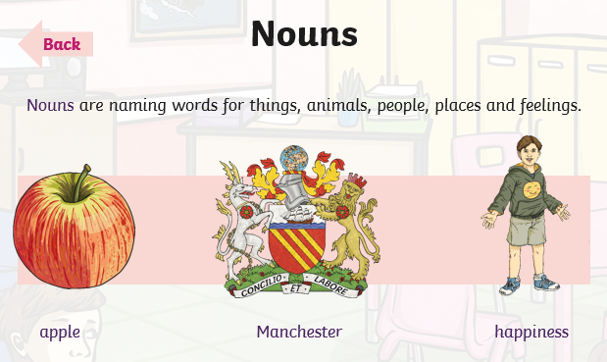 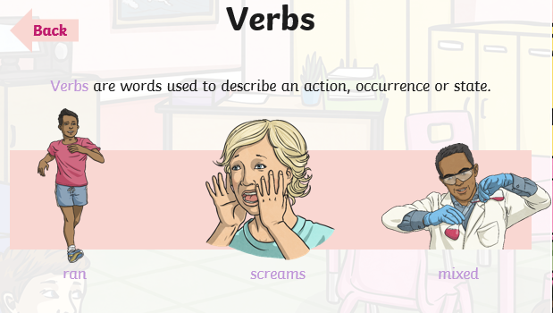

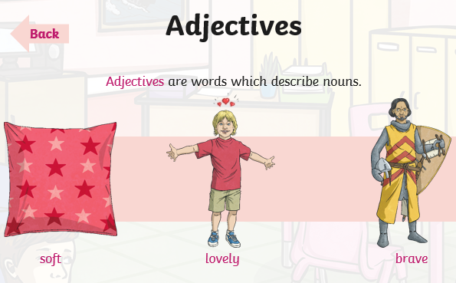 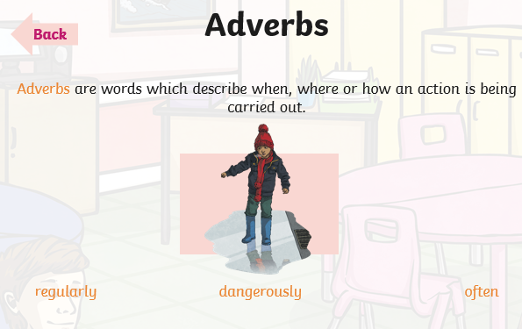

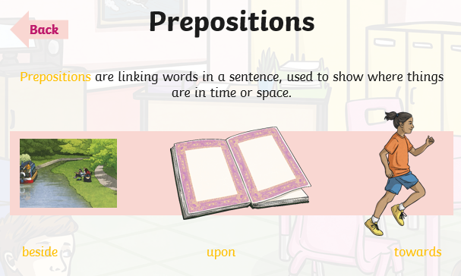

Prepositional phrases are more than one word which describes where or when something is. Examples of these could include:

At the side of, a few moments later, next to the lake etc.

Resource sheet 7 – Wed 10.2.21

Identify the different types of words in the paragraph below.

It was a clear, warm night. An owl hooted softly. A small boat bobbed on the lake and from time to time the water gently lapped against it. Moonlight hit the ripples on the lake, reflecting little sparks of light like diamonds on the water. In the distance, the outline of the towering mountains cast dark shadows, menacingly across the tranquil lake. Tall trees with thick trunks edged the water and birds roosted in their tangled branches. A short pathway led to a camping area. In the middle of the camp, a fire crackled with red embers. By the fire, a fallen log was being used as a seat, by a young boy, who had pitched his tent for the night.

|  |  |
| --- | --- |
| Word class | Colour |
| nouns |  |
| adjectives |  |
| verbs |  |
| adverbs |  |
| prepositions |  |

Bronze – identify 5 nouns, 5 adjectives, 3 verbs, 2 adverbs and 3 prepositions or prepositional phrases.

Silver – identify 8 nouns, 6 adjectives, 5 verbs, 2 adverbs and 5 prepositions or prepositional phrases.

Gold – how many of each word class can you find? Can you find them all?

Resource sheet 8 – Thurs 11.2.21

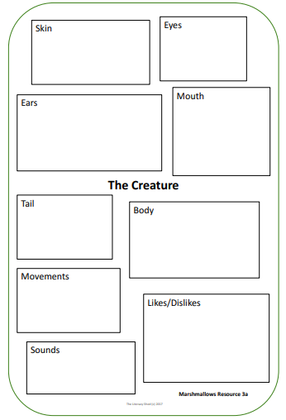

Resource sheet 9 – Fri 12.2.21 AND Thurs 25.2.21 (PLEASE SAVE)

Use your own openers or some of these openers to improve the sentences on the next resource sheet.

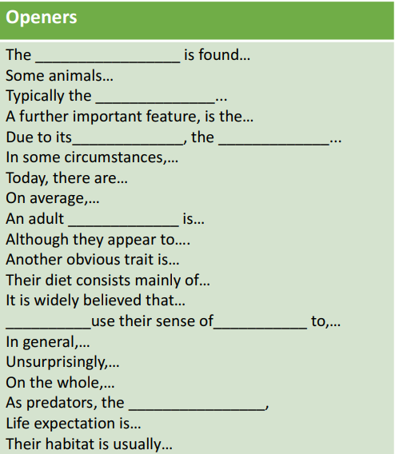

Resource sheet 10 – Fri 12.2.21

These sentences about the marshmallow monster have very repetitive openers. Using resource sheet 9, or ideas of your own, rewrite and improve the sentences with varied openers. You may also need to structure the information differently too.

1. The marshmallow monster is semi aquatic, living both on land and in water.

_____________________________________________________________________________________________________________________________________________________________________________________________________________________________________________________________________

1. The monster eats mainly marshmallows, but also enjoys gummy bears if any can be hunted.

_____________________________________________________________________________________________________________________________________________________________________________________________________________________________________________________________________

1. The monster’s body is covered in scales, which are green and white.

________________________________________________________________________________________________________________________________________________________________________________________________________________________________________________________________________

1. It can be quite tame but also dangerous when hungry.

_____________________________________________________________________________________________________________________________________________________________________________________________________________________________________________________________________

1. It is a rare species and there are only one hundred left worldwide.

_____________________________________________________________________________________________________________________________________________________________________________________________________________________________________________________________________

Resource sheet 11 – Mon 22.2.21

Examples of basic non-chronological reports

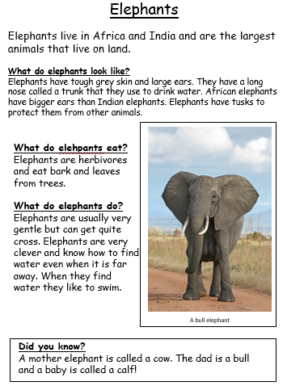

Resource sheet 12 – Mon 22.2.21

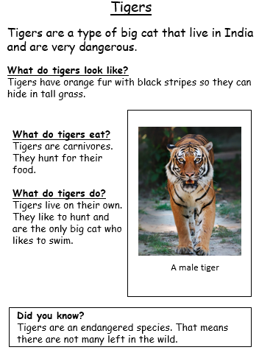

Resource sheet 13 – Mon 22.2.21

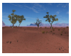**The Donriphant**

The donriphant is a large land mammal, usually found on the African continent, though fossils of a mammal similar to the donriphant have been found in South America.

Appearance

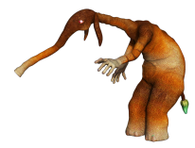The donriphant is large; adult males often weigh up to 3500kg. It has thick, wrinkled skin, which helps to keep it cool in the African heat and a short green-tipped tail, which is covered in coarse, wiry hairs, and is used for balance. Two arm-like limbs help it to climb trees, and its hands are capable of gripping and utilising tools. Its long neck is useful when gathering vegetation, and strong, flexible muscles allow the creature to extend its neck by a further 15-20 cm, when needed. The donriphant has two long ears which are used as cooling devices. As temperatures climb, the donriphant rotates its ears in a circular motion to cool the head and trunk. Typically, the donriphant walks in an upright stance and uses the large pads on the soles of its feet for stability, though it can run for short bursts on four legs.

A donriphants typical habitat

Short green tipped tail

Two long ears

Hands used for gripping

Feeding

The animal’s body is designed to reach the leaves and branches from the top of trees. Typically, an adult male will eat around 30-35kg of leaves a day. Leaves provide the donriphant with some of its water and the rest is consumed at the watering holes, often in large groups. Mainly found living in herds, the donriphant is well adapted to live in a hot, dry climate and, like a camel, it can store fat to keep it nourished on long journeys.

Did you know?

Due to its large size, the donriphant has very few predators. Adult deaths are more likely to be caused by crocodiles, which strike in the rivers and watering holes.

Predators and prey

Hyenas will often work in packs to separate young, or weak, animals from the rest of the herd. In some circumstances, lions will target a lone donriphant, though are unlikely to pursue a herd.

Resource sheet 14 – Mon 22.2.21

Now that you have recapped your mind about non-chronological reports and their features, see if you can identify the features in the report about the Doriphant. Choose your level of work and find the features in the text, use different colours to identify them and produce a key, using the relevant chart from below.

Gold

|  |  |  |  |
| --- | --- | --- | --- |
| heading |  | captions |  |
| introductory paragraph |  | paragraphs |  |
| subheadings |  | factual information |  |
| diagrams/images |  | technical vocabulary |  |
| third person |  | preset tense |  |
| labels |  | fact box |  |

Silver

|  |  |  |  |
| --- | --- | --- | --- |
| heading |  | captions/labels |  |
| introductory paragraph |  | preset tense |  |
| subheadings |  | factual information |  |
| diagrams/images |  | technical vocabulary |  |

Bronze

|  |  |  |  |
| --- | --- | --- | --- |
| heading |  | captions/labels |  |
| introduction paragraph |  | diagrams/images |  |
| subheadings |  | factual information |  |

Resource sheet 15 – Tues 23.2.21

Draw a detailed picture of your new creature. Include as much detail as possible.

Resource sheet 11 - Mon 1.2.21

Resource sheet 12 – Tues 2.2.21

Resource sheet 13 – Wed 3.2.21

Resource sheet 15 – Thurs 4.2.21

Use this support sheet to help you when writing your letter.

Resource sheet 16 – Thurs 4.2.21/Fri 5.2.21

Choose your success criteria Gold, Silver or Bronze

|  |  |  |
| --- | --- | --- |
| j0434395Persuasion Success Criteria- Gold | Self | Teacher |
| Have I expanded the reasons for my argument with extra detail? |  |  |
| Have I used an opening paragraph to introduce the point of view being argued? |  |  |
| Have I included three different reasons as to why my side of the argument is right? |  |  |
| Have I used at least six different persuasive techniques? |  |  |
| Have I included a conclusion that persuades the reader that I am right? |  |  |
| Have I organised my letter into paragraphs? |  |  |
| Have I used accurate sentence punctuation, including question marks, exclamation marks and commas? |  |  |

Resource sheet 16 – Tues 23.2.21

Now complete this sheet again, but this time, include details and description of YOUR creature.

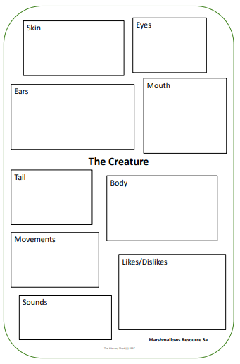

Resource sheet 17 – Wed 24.2.21

Use this planning sheet to organise your report from yesterday’s work.

Heading

Introductory paragraph (How will you introduce your report)

Vocabulary

Paragraph 3 subheading:__________________________________

Paragraph 2 subheading:___________________________________

Paragraph 1 subheading:__________________________________

Fact box/Did you know?

Resource sheet 18 – Wed 24.2.21

Use this resource sheet to help to choose some vocabulary to use in each paragraph.

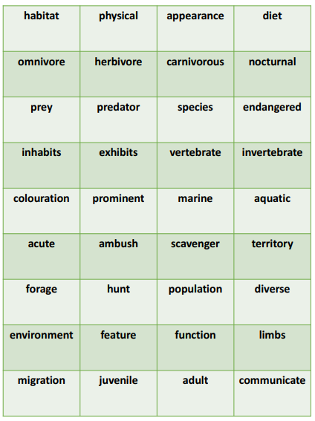

Resource sheet 19 – Thurs 25.2.21

Choose your success criteria before writing your report.

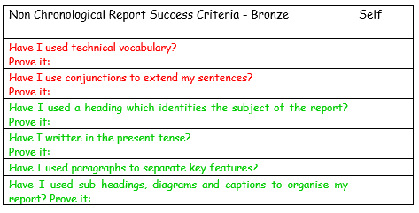

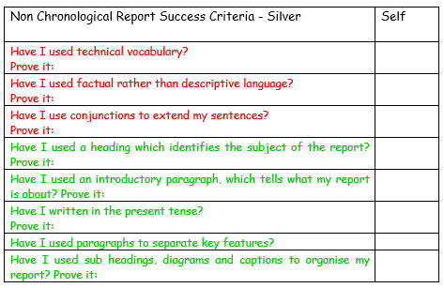

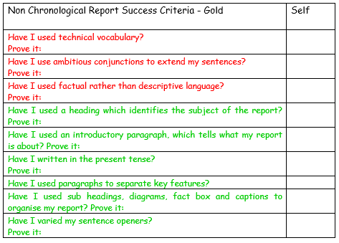

Resource sheet 20 – Thurs 25.2.21



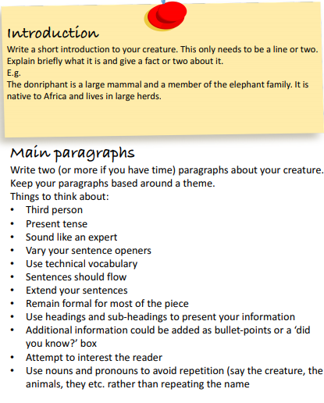

Resource sheet 21 – Thurs 25.2.21

____________________________________________________________________________________________________________________________________________________________________________________________________________________________________________________________________________________________________________________________________________________________________________________________________________________________________________________________________________________________________________________________________________________________________________________________________________________________________________________________________________________________________________________________________________________________________________________________________________________________________________________________________________________________________________________________________________________________________________________________________________________________________________________________________________________________________________________________________________________________________________________________________________________________________________________________________________________________________________________________________________________________________________________________________________________________________________________________________________________________________________________________________________________________________________________________________________________________________________________________________________________________________________________________________________________________________________________________________________________________________________________________________________________________________________________________________________________________________________________________________________________________________________________________________________________________________________________________________________________________________________________________________________________________________________________________________________________________________________________________________________________________________________________________________________________________________

__________________________________________________________________________________________________________________________________________________________________________________________________________________________________________________________________________________________________________________________________________________________________________________________________________________________________________________________________________________________________________________________________________________________________________________________________________________________________________________________________________________________________________________________________________________________________________________________________________________________________________________________________________________________________________________________________________________________________________________________________________________________________________________________________________________________________________________________________________________________________________________________________________________________________________________________________________________________________________________________________________________________________________________________________________________________________________________________________________________________________________________________________________________________________________________________________________________________________________________________________________________________________________________________________________________________________________________________________________________________________________________________________________________________________________________________________________________________________________________________________________________________________________________________________________________________________________________________________________________________________________________________