Tuesday, 2nd March – World Book Week 2021
LO: To write an acrostic poem based on the story ‘Flotsam’
F ______________
L ______________
O______________
T______________
S______________
A______________
M______________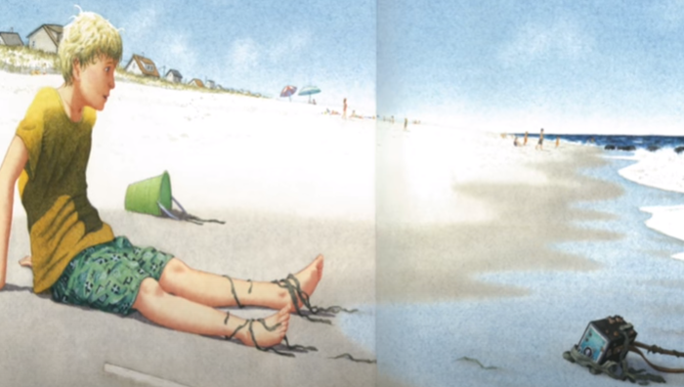
Wednesday, 3rd March – World Book Week 2021
LO: To create and label underwater pictures using adjectives
Draw the photographs you would take and then label them using adjectives (you could print pictures if you would rather). If you use two adjectives together, remember to use a comma between them: long, wavy tentacles
Photograph One | Labels  _______________________  _______________________  _______________________
Labels  _______________________  _______________________  _______________________ | Photograph Two
Photograph Three | Labels  _______________________  _______________________  _______________________

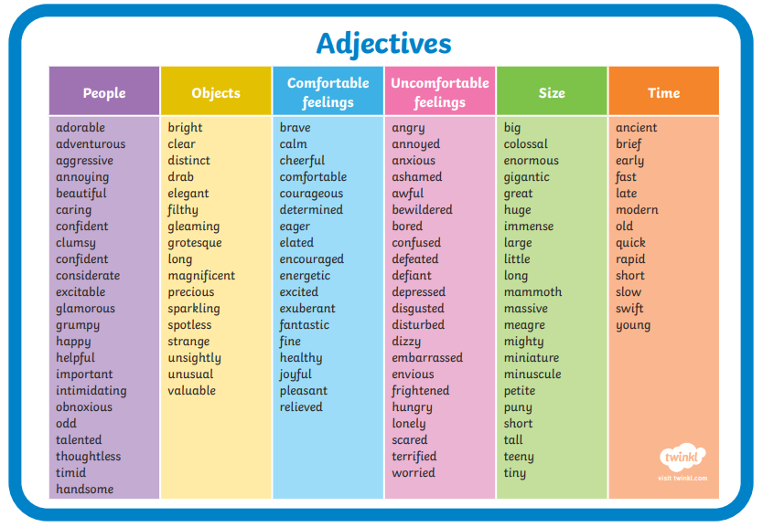
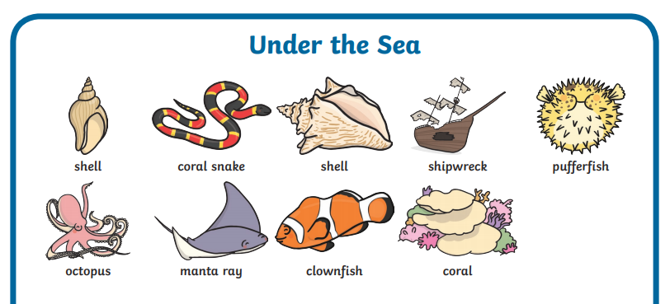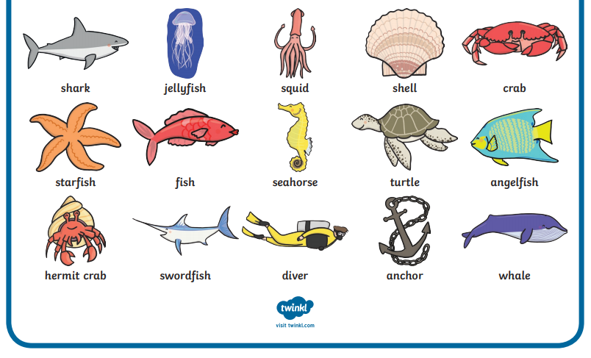
Thursday, 4th March – World Book Week 2021
LO: To imagine what a character may say or think
Imagine what the boy might be saying or thinking during the story. Write full sentences using capital letters, full stops, exclamation marks and question marks!
________________________________

________________________________

________________________________
__________________________________________

__________________________________________

__________________________________________

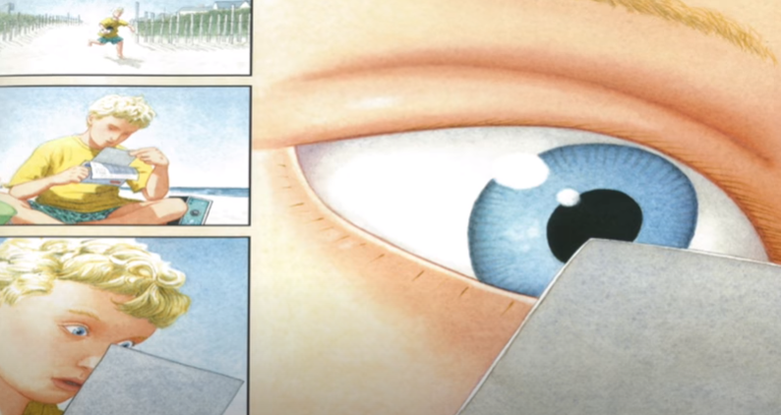
___________________________________________

___________________________________________

___________________________________________

Friday, 5th March – World Book Week 2021
LO: To write a short story based on Flotsam in 100 words or less!
Time to make a mini-plan – draw a picture from the beginning, middle and end of the story. Write a short sentence or idea for each. Then attempt the challenge in the story frame below!
Mini-Plan
Beginning | Middle | End
______________________  ______________________  ______________________ | ______________________  ______________________  ______________________ | ______________________  ______________________  ______________________
Here is an example of a short story based on Flotsam with less than 100 words – you can write an even better version!

Flotsam

Standing on the seashore, something bumped my toe. It was an underwater camera covered in tiny, rough barnacles! I held the small, dark box in my hands and wondered what it had seen. The film showed bright, colourful images of coral, sea creatures from the deep blue sea, shiny, red crabs and children playing and taking picture after picture – children just like me! I snapped my own sunny shot and then threw the camera with all my might, straight back in to the rushing, noisy waves of the ocean. It landed with a SPLASH and then disappeared… for now…
(99 words)
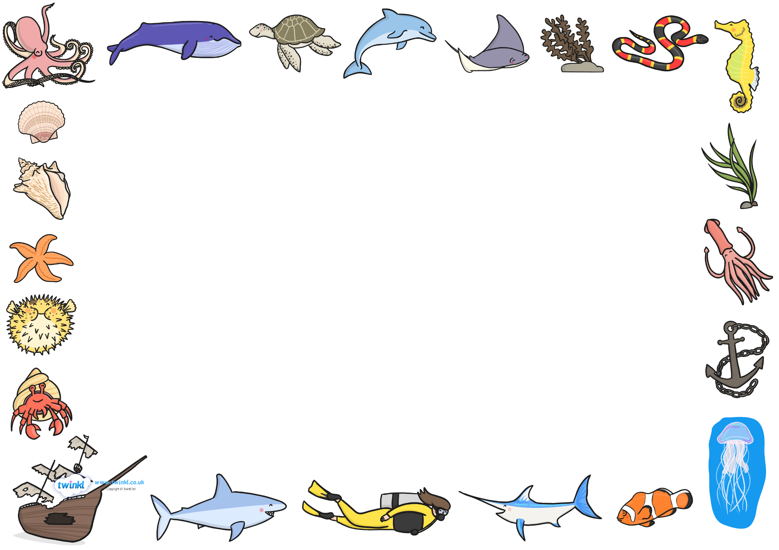

Flotsam by .

____________________________________________________________

____________________________________________________________

____________________________________________________________

____________________________________________________________

____________________________________________________________

____________________________________________________________

____________________________________________________________

____________________________________________________________

____________________________________________________________

____________________________________________________________

____________________________________________________________

____________________________________________________________

____________________________________________________________

