Hillside Book Tasting  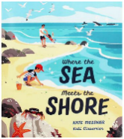  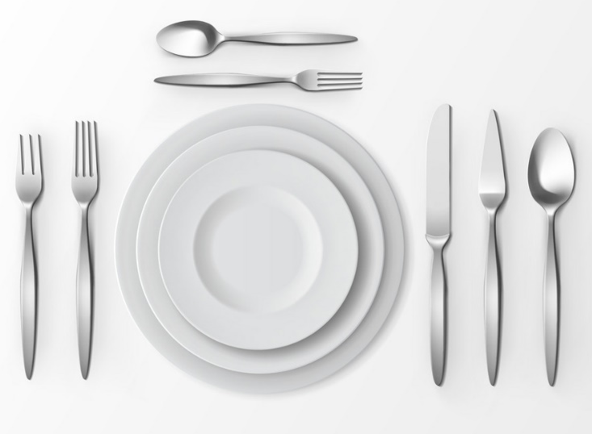  Book Week 2021  Tasted by:  _________________________________ | Where the Sea Meets the Shore  by Kate Messner  Do you like the front cover?  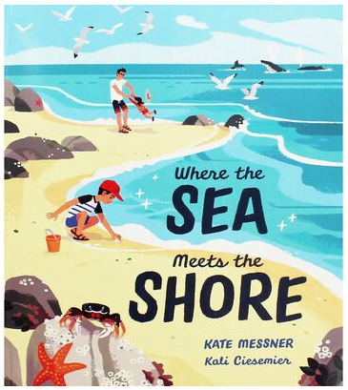  Is it fiction (a made up story) or non-fiction (full of facts)?  Fiction Non-fiction  What is the book about?  _________________________________  __________________________________________________________________  _________________________________ | What was your favourite part and why? (Use because!)  _________________________________  _________________________________  _________________________________  _________________________________  Draw a picture of your favourite part of the story.  Did you enjoy the story?  Yes No  Star rating
