
Book Week 2021
Year One
Day | 9:00-9:30 | 9:30-9:50 | 9:50- 10:50 |  | 11:00-12:00 |  | 1:00-2:00 | 2:00- 2:45 |  | 2:45-3:00
Mon | Morning Zoom Call: Guess the Book Game  Your teacher will give you some clues or props. Can you guess the book? | Whole Class Phonics | Book Tasting of your gifted book- see English PowerPoint  (Day 1) | B | Maths- see additional grid for links and resources. | L | Underwater Adventure!  Grab your popcorn; put your feet up and use the following links to go on a virtual tour of the London Aquarium (you could pretend we’re on a school trip!)  https://www.youtube.com/watch?v=fjpEHiccLD0  then have a watch of this underwater adventure!  https://www.youtube.com/watch?v=n4tzUnGv-yI  Follow up Task:  In your gifted book, there are different facts about sea creatures in the back! Choose your favourite and create an underwater sea picture featuring them! Add labels and information if you choose or just enjoy being arty and creative! |  |  | Drop Everything and Read  Snuggle up with a good book.
Tues | Morning Zoom Call:  Introduction of whole school text: Flotsam by David Wiesner  Flotsam By David Wiesner - YouTube | Whole Class Phonics | Create your own acrostic poem based on ‘Flotsam’ - see English PowerPoint  (Day 2) | R | Maths- see additional grid for links and resources | U | PE  Join Jaime  https://www.youtube.com/watch?v=zSgEH_4itws  and find out about Norris the seahorse! (This is an extended link but can be shortened as you wish) |  | Music  Join Mr Hall for a music lesson  https://www.youtube.com/channel/UCodMAOaH0jZzcEcBesCgyJA/featured  or why not create your own underwater poem or song? | Drop Everything and Read  Snuggle up with a good book.
Wed | Morning Zoom Call: Bring your favourite book along to show the rest of the class. | Whole Class Phonics | Take three of your own underwater pictures and add labels using adjectives - see English PowerPoint  (Day 3) | E | Maths- see additional grid for links and resources. | N | Book Quiz:  Open the Book Quiz PowerPoint and see how many questions you can answer correctly.  Why not encourage other family members to play along and see if you can beat their score. Good Luck! |  |  | Drop Everything and Read  Snuggle up with a good book.
Thurs | Morning Zoom Call: Pyjamas only allowed, grab yourself a hot drink and a piece of toast/biscuit and see which teacher has swapped places with your usual class teacher and will be reading you a story! | Whole Class Phonics | Imagine you are the character in the story. What would he say and think? – see English PowerPoint  (Day 4) | A | Maths- see additional grid for links and resources. | C | Reading Menu:  Pick two activities to complete from the reading menu below.  There are template ideas, recipe links and examples to help you pictured below. |  |  | Drop Everything and Read  Snuggle up with a good book.
Fri | Morning Zoom Call:  Share photographs of children’s Book Cover Challenge photographs’  Certificates awarded also. | Whole Class Phonics | English Story Planning – See English PowerPoint  (Day 5)  (You may wish to begin your creative writing in this session too!) | K | Maths- see additional grid for links and resources. | H | Creative writing competition – create a story using only 100 words or less!  (See English PowerPoint)  If you complete your creative writing competition in the morning, you may wish to choose another activity from the reading menu below. |  |  | Drop Everything and Read  Snuggle up with a good book.
Whole School ‘Book Cover’ Challenge: (Optional Activity)

We are challenging you to recreate a book cover of your choice. Get creative by using props, dressing up clothes and even your pets to recreate the front cover of a book. Send your entries into your class home learning email by Thursday 3rd March at 3pm to be in with a chance of winning a prize!
Please send in two photos: one of the original front cover of the book and one of your recreation. We can’t wait to see what creative ideas you come up with!
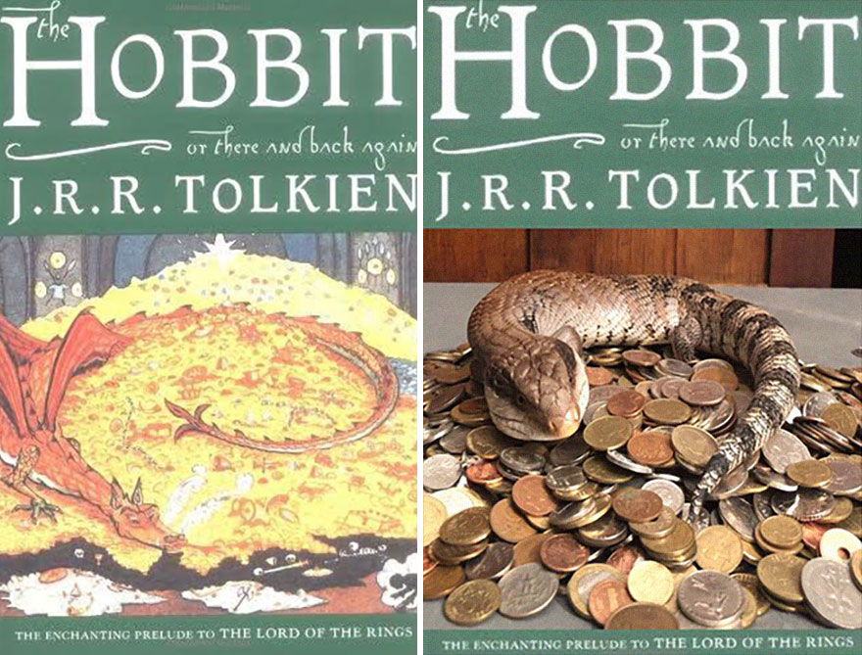
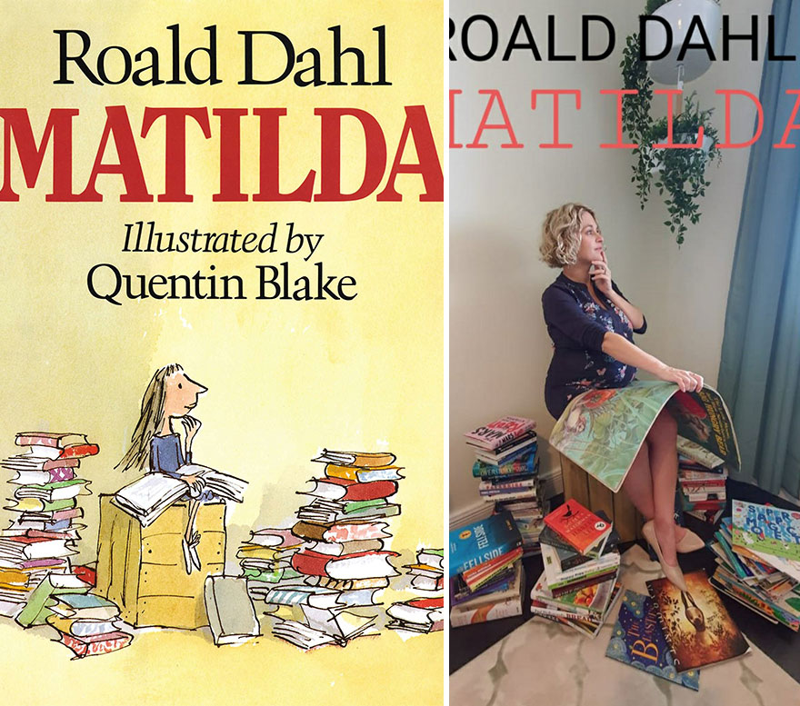
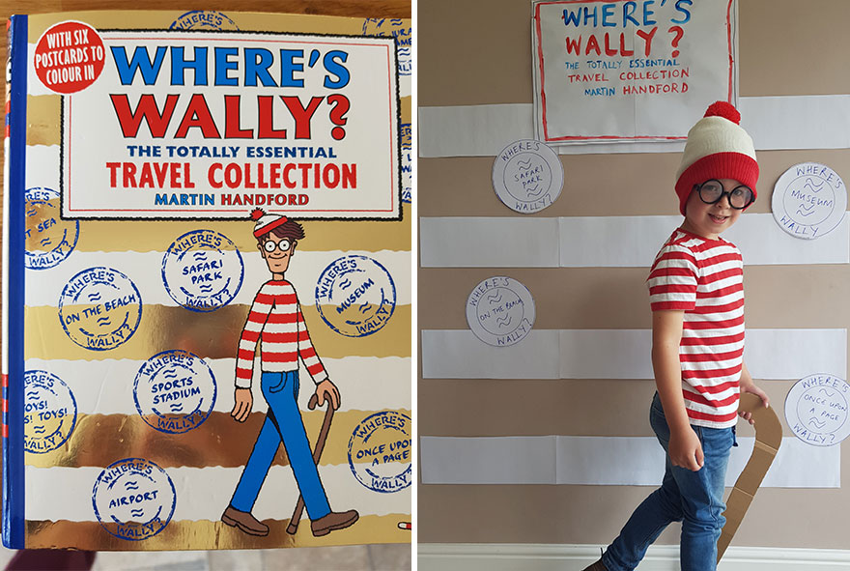

Book Day Menu (Thursday)
Create a book review or poster to encourage other people to read a book of your choice. Use the book review template to guide you.  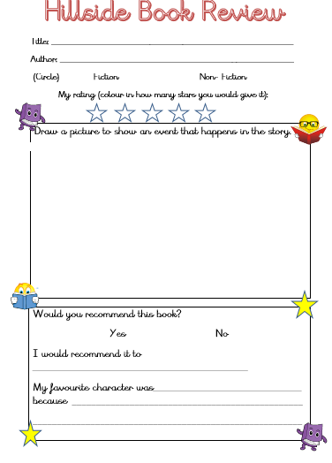 | Create a bookmark with a design of your favourite book. Colour it in and when we return to school, bring it in and we will laminate it for you to keep forever!  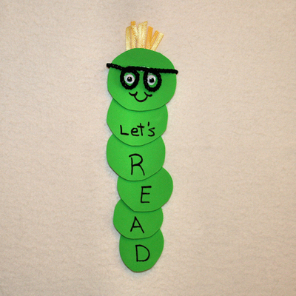 | Create a story inspired sweet treat. Get in the kitchen and create your very own Gruffalo crumble, Bruce Bogtrotter chocolate cake or go all out and create a Mad Hatter’s Tea Party!  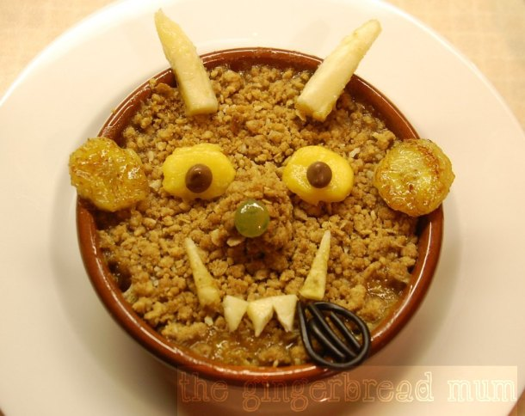  https://www.food.com/ideas/childrens-book-recipes-6304#c-51855
Research your favourite author and create a quiz all about their life and books. Send the quiz to your class teacher and see how they score.  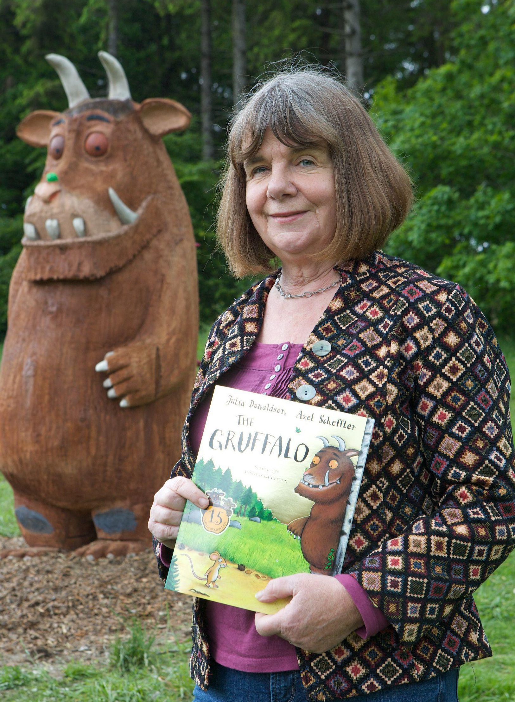 | Go on a ‘Bear Hunt’ in your local area. Remind yourself of the story before you go by watching the following video.  https://www.youtube.com/watch?v=0gyI6ykDwds  On your walk, go through the mud, squelch, squelch! Or through the grass, swishy, swashy! Or through the forest, stumble trip, stumble trip!  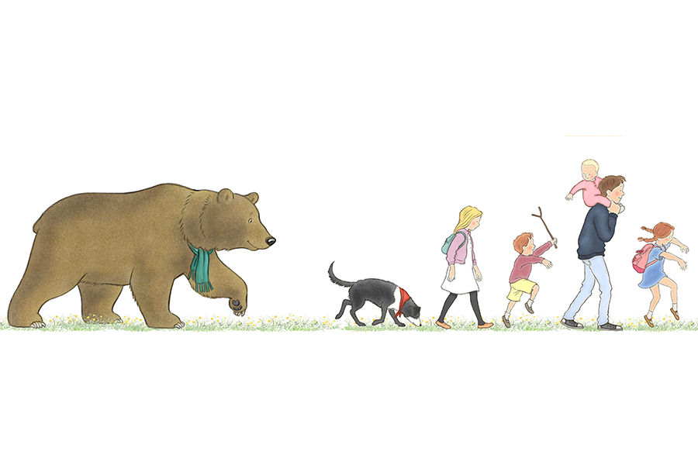 | Use the templates below as a guide to create some story character masks. Colour, collage or paint them. Once your masks are ready, ask your family members to act out a story with you or why not put on a one-person show and play all of the parts in your story? You could quickly change your mask as each different character talks.  

