Communication, Language & Literacy  Talk to a grown up about how to stay safe near water. What is a life jacket? Why do we need to wear them? What other equipment might you need to stay safe when on a boat?  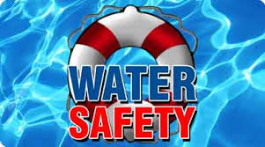 | Expressive Arts &Design  Can you print a sailboat using a potato? Ask a grown up to help you cut a semi-circle and two triangles. Don’t forget to add the mast.  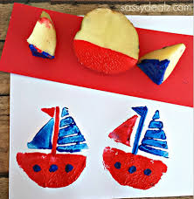 | Understanding the World/P.S.E.D  Talk to a grown up or sibling about your hopes and dreams for your next school year in Reception. What new things would you like to learn? Are you excited to meet your new teacher?  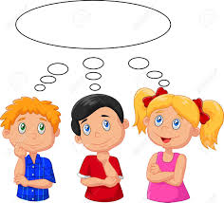
Understanding the World  Investigate which items float or sink. Some items may float to start with and then sink! You could use sponges. Metal spoons, bottle top lids, corks, boxes etc. Can you guess before you put them in the water?  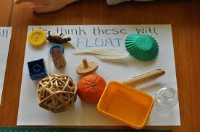 | Physical Development  Hold your own Sports Day along with the rest of Hillside Primary School. Click on the hyperlink below to access the sports day resources  https://hillsideprimary.org.uk/virtual-sports-day/ | Expressive Arts & Design  Can you build a boat using junk modelling materials such as milk bottles, plastic containers, straws, lids etc Test your boat in the bath or sink. Does it float or sink?  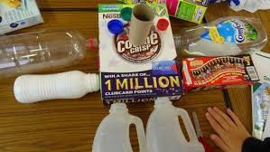
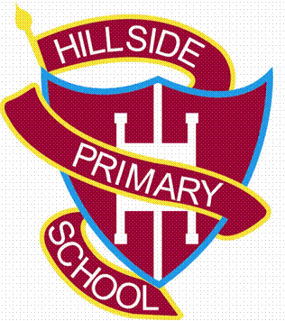
Hillside Primary School
Home Learning Grid – Nursery –Week 13 & 14
Topic –Travel and Transport

Literacy – Reading  Log onto Purple Mash or the Oxford Owl website to complete a phonics or reading activity.  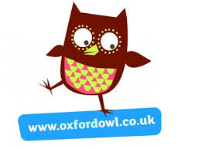 | Literacy-Writing  Can you draw a picture of one of your favourite activities/events during your time in Nursery. It might be the train ride at Amerton Farm, watching the pantomime, climbing on the agility trail or playing with your favourite toys.  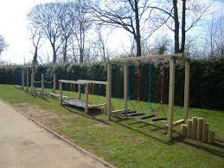 | Literacy- Phonics  Wash the Word  Ask a grown up to write some cvc words outside in chalk. Listen to the word being sounded out., then find the word and wash it away  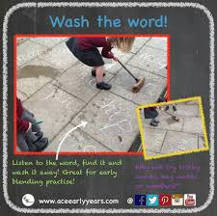
Maths-shape  2D shape boats  Can you make a picture of a boat using as many 2D shapes as you can? How many sides and corners do the shapes have?  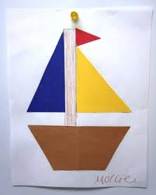 | Maths-number  Using boat and sail shapes, with numbers up to 5, can you add the two sails together, then match the correct boat with the answer? You could challenge yourself by adding numbers to 10.  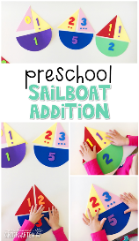 | Maths-Measures  Use your bath or kitchen sink to investigate different containers and how much water they can hold. You could use spoons, jugs or ladles to pour the water. Which container holds the most and the least?  