Understanding the World  Fizzing magic potion  Click on the link below for a recipe to make a simple magical potion.  https://theimaginationtree.com/science-activity-fizzing-fairy-potions/  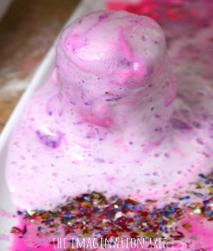 | Communication & Language  Make up your own story about a wizard or a princess like the story of ‘The Princess and the Wizard’ by Julia Donaldson.  Think about the characters, setting, a problem that might occur and an ending. Can you tell your story to your family. You could create a storyboard of pictures to help you.  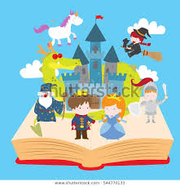 | Understanding of the World  Create your own sugar crystal magic wands. See below for instructions.  https://www.youtube.com/watch?v=-oUUkAT6xeA  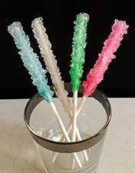
Personal, Social, & Emotional Development  Talk to a grown up or sibling about your hopes and dreams for your next school year in Year 1. What new things would you like to learn? Are you excited to meet your new teacher? As part of this activity, you could create a powerpoint about yourself to send into school. | Physical Development  Hold your own Sports Day along with the rest of Hillside Primary School. Click on the hyperlink below to access the sports day resources  https://hillsideprimary.org.uk/virtual-sports-day/ | Expressive Arts & Design  Using resources found in your garden or on one of your daily walk, make a magical wand fit for a wizard. You could use sticks, leaves, wool ribbons and any other crafty resources you have at home. Can you learn a simple magic spell to recite as you wave your wand.  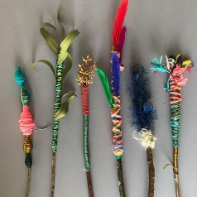
Hillside Primary School
Home Learning Grid – Reception –Week 13 &14
Story- The Princess and the Wizard

Literacy – Writing  Can you draw a picture of one of your favourite activities/events during your time in Reception. Then write a sentence or two describing this activity and why you enjoyed it. Don’t forget to use your sound mat. It might be the trip to the Ice-cream Farm watching the pantomime, climbing on the agility trail or playing with your favourite toys.  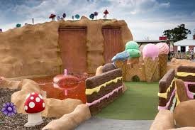 | Literacy-Reading  Click on the link to listen to the story of  ‘The Princess and the Wizard  https://www.youtube.com/watch?v=yxGMWignl6o 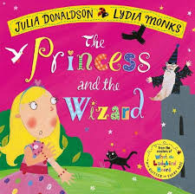  Questions linked to this story are attached below.  Don’t forget to check out https://www.oxfordowl.co.uk/for-home/find-a-book/library-page/  For more reading opportunities. | Literacy- Phonics  Create your own rhyming strings using the sounds below. Link attached but you can also write your own lists.  https://www.twinkl.co.uk/resource/-phase-3-phonics-rhyming-string-cards-t-l-9528  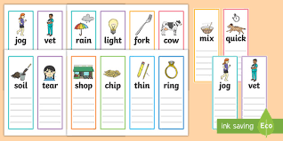
Maths-Pattern  https://wrm-13b48.kxcdn.com/wp-content/uploads/2020/06/Day-1-The-Princess-and-the-Wizard.pdf  Sing the days of the week song to help you complete this activity.  https://www.youtube.com/watch?v=8GKmCQOy88Y  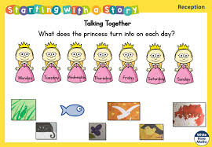 | Maths-Number  https://wrm-13b48.kxcdn.com/wp-content/uploads/2020/06/Day-4-The-Princess-and-the-Wizard.pdf  The wizard has been doubling everything so there's far too much food at the princesses party! Can you collect groups of objects from around your house that you can halve/share with your grown up.  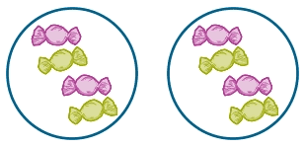 | Maths- Shape  https://wrm-13b48.kxcdn.com/wp-content/uploads/2020/06/Day-5-The-Princess-and-the-Wizard.pdf  Create your own symmetrical crown using items from your house.  