The Princess and the Wizard
By Julia Donaldson and Lydia Monks

- What special occasion was Eliza celebrating?
- How old was Eliza?
- Give two reasons you know that the Wicked Wizard is angry?
- Why wasn’t the Wicked Wizard invited to the party?
- How did the Fairy Godmother say that Eliza could escape?
- What day did the Wicked Wizard lock the princess up?
- Why did the Wicked Wizard begin to count to 100?
- What is a moat?
- Why was Eliza able to turn herself into a blue fish?
- How many chances to escape does Eliza have once the Wicked Wizard finds her in the moat?
- Why did the yellow socks have holes in them?
- Where did the Wicked Wizard lock Eliza up on Wednesday?
- What was covered all over the walls of the bathroom?
- What did the Wicked Wizard do each time he caught Eliza?
- What clever idea did Eliza have to escape the Wicked Wizard?
- Why did the Wicked Wizard fly into a rage?
- How did the King, Queen and party guests come back to life?
- How did Eliza get back home?
- Who did Eliza, her family and friends have to thank for saving them?
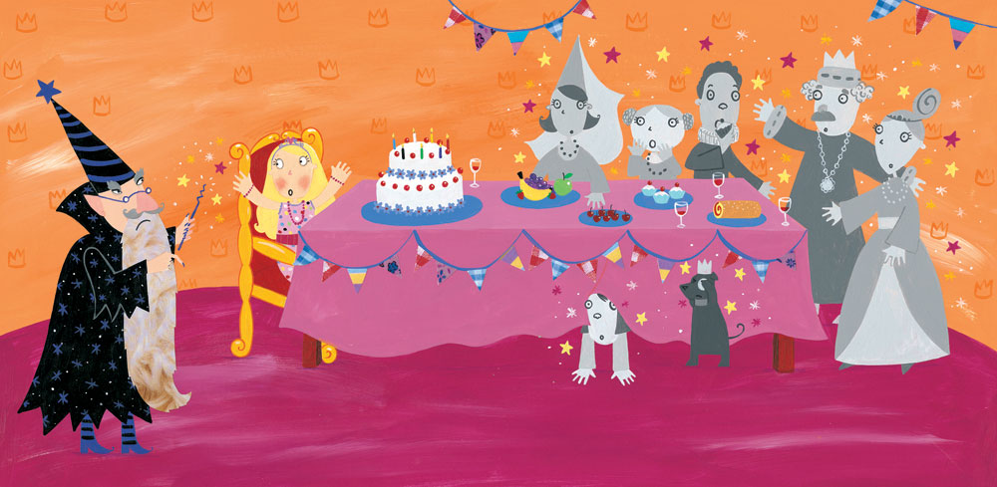

Write a letter from Eliza to the Fairy Godmother thanking her for helping Eliza to escape.
PLAN
Name

Address
Postcode
Date
Dear …,
I am writing to you….
Tell the Fairy Godmother about what happened while you were locked up.

What was the worst thing?
How did you feel?
What would have happened if you didn’t escape?
Tell the Fairy Godmother what you plan to do to thank her.
From,

Write a diary entry for one particularly horrible day locked up in the castle.
PLAN
Dear Diary,
Today…

What happened today?
How are you feeling?
What are your feelings about the Wicked Wizard?
What do you wish would happen to him?
What is your plan for tomorrow?
Do you think it will work?
How will you feel if it doesn’t work?
Goodnight/Bye for now
Date

