Maths Home Learning Grid – Mrs Wainwright’s Group Year 6
Week Commencing: 6.7.20 and 13.7.20 (Two-Week Cycle)
Maths- Activity 1  https://whiterosemaths.com/homelearning/year-6/  Use the following link and go to Summer Term Week 9  (22nd June), Lesson 1 –  Area and Perimeter  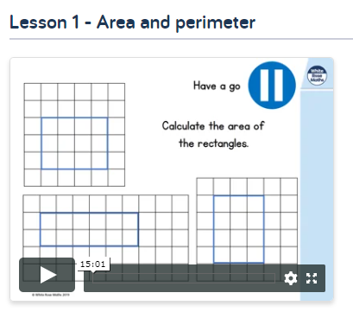 | Maths- Activity 2  https://whiterosemaths.com/homelearning/year-6/  Use the following link and go to Summer Term Week 9  (22nd June), Lesson 2 –  Area of Triangles  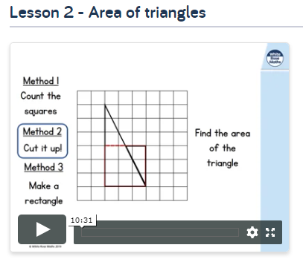 |  | Maths- Activity 3  https://whiterosemaths.com/homelearning/year-6/  Use the following link and go to Summer Term Week 9  (22nd June), Lesson 3 –  Area of Parallelograms  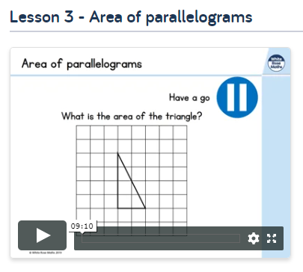
Maths- Activity 4  https://whiterosemaths.com/homelearning/year-6/  Use the following link and go to Summer Term Week 9  (22nd June), Lesson 4 –  Volume of Cuboids  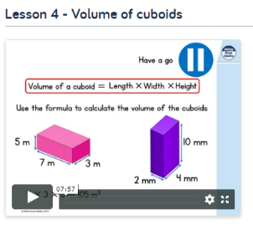 | Maths- Activity 5 and Activity 6  Your challenge is to plan a family holiday for a fictional family: The Ramsey Family.  The family would like to travel to Australia and you have to calculate:  - The cost of the holiday including flights and accommodation  - How much it will cost to hire a car during their stay  - How much it will cost to take part in the activities they have proposed  - A new passport for their daughter, Charlene.  What will be the total cost of the dream trip for the Ramsey family?
Times Table Focus:  Concentrate on a times tables of your choice. Which do you struggle with the most? Your 7s? Your 12s? Spend the next two weeks practising them every day and ask family members to test you throughout the day. |  | Key Skills Practice  Play at least five different games on the Topmarks website: Try and pick a variety of maths topics e.g. shape, number, measure etc.  https://www.topmarks.co.uk/Search.aspx?q=year%206%20maths

