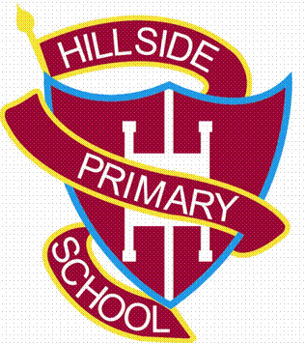
Hillside Primary School Reading Questions for Nursery and Reception
Questions to ask your child when reading – Early Years
Before reading the book:
- Can you point to the title? or What is this? (pointing to the title)
- What do you think this story will be about? What might happen in the story?
- Who is in the story?
During the reading of the book:
- What is happening here?
- What is ______ doing?
- • What might happen next?
- How do you think the story might end?
- Is __________ friendly/ mean/ nice…?
- What does ______ mean? (To check understanding of a word)
At the end of the book:
- Did you like this book? Why?
- What was your favourite part? Why?
- Which character did you like the best? Why?
- Why did that character do … (give a situation/ event from the story)?
- What happened in the story?

