Maths Home Learning Grid –Year 3
Maths- Activity 1  https://whiterosemaths.com/homelearning/year-3/  Use the following link and go to Summer Term- Week 3, Lesson 1- Convert pounds and pence  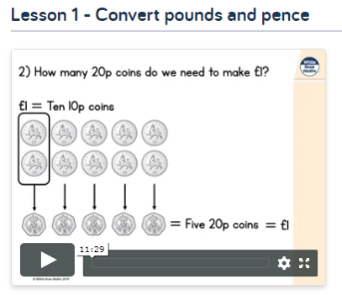 | Maths- Activity 2  https://whiterosemaths.com/homelearning/year-3/  Use the following link and go to Summer Term- Week 3, Lesson 2- Add money  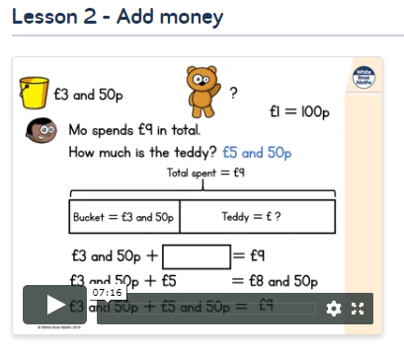 |  | Maths- Activity 3  https://whiterosemaths.com/homelearning/year-3/  Use the following link and go to Summer Term- Week 3, Lesson 3- Subtract money  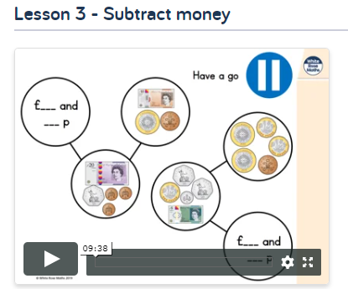
Maths- Activity 4  https://whiterosemaths.com/homelearning/year-3/  Use the following link and go to Summer Term- Week 3, Lesson 4- Multiply and divide by 3  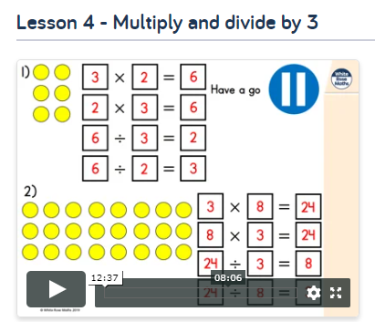 | Maths- Activity 5  https://whiterosemaths.com/homelearning/year-3/  Use the following link and go to Summer Term- Week 4, Lesson 1- Multiplying and dividing by 4 and 8  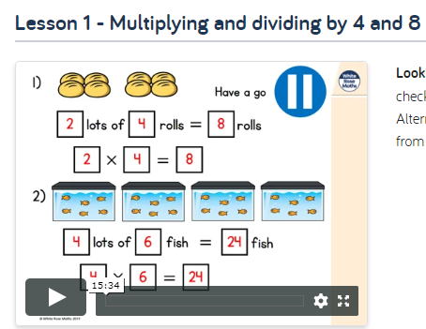
Times Table Focus:  Concentrate on your 3, 4 and 8 times tables. Do you know them and their corresponding division facts at speed? Get an adult to time how quickly you can write down the multiplication and division facts.  Remember to go on TTRS to practise all of your times tables. |  | Key Skills Practice  Can you count up in multiples of 50?  Have a go and see how far you can go. Then have a go at writing them down. Is there a pattern?
Week Commencing: 18.05.20 and 01.06.20 (Two Week Cycle)

