Maths Home Learning Grid – Year Four
Week Commencing: 18.5.20 and 1.6.20 (Two Week Cycle)
Maths- Activity 1  https://whiterosemaths.com/homelearning/year-4/  Use the link and go to Summer Term Week 3 (w/c 4th May), Lesson 1 –  Multiply 2 digit number by 1 digit number  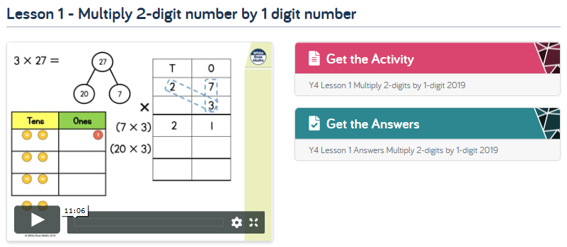 | Maths- Activity 2  https://whiterosemaths.com/homelearning/year-4/  Use the link and go to Summer Term Week 3 (w/c 4th May), Lesson 2 –  Multiply 3 digit number by 1 digit number  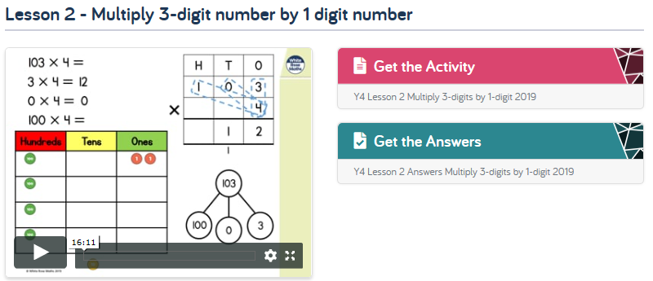 |  | Maths- Activity 3  https://whiterosemaths.com/homelearning/year-4/  Use the link and go to Summer Term Week 3 (w/c 4th May), Lesson 3 –  Divide 2 digit by 1 digit number  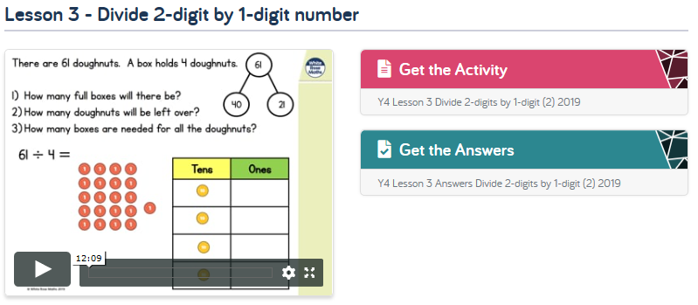
Maths- Activity 4  https://whiterosemaths.com/homelearning/year-4/  Use the link and go to Summer Term Week 3 (w/c 4th May), Lesson 4 –  Divide 3 digit by 1 digit number  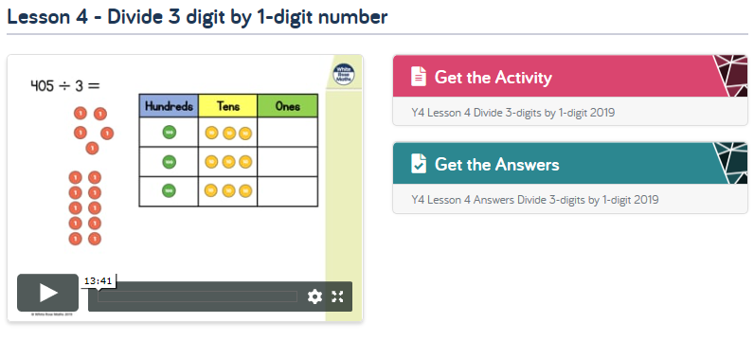 | Maths- Activity 5  https://whiterosemaths.com/homelearning/year-4/  Use the link and go to Summer Term Week 4 (w/c 11th May), Lesson 1 – Multiplying and dividing problem solving – worksheet provided  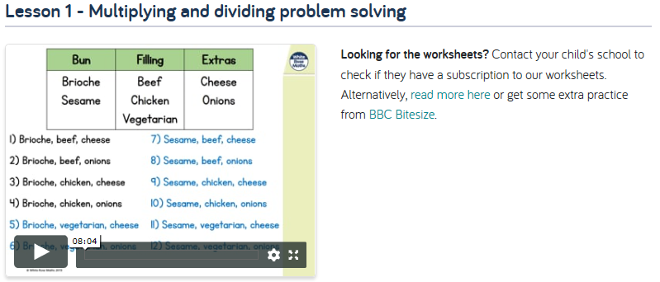 |  | Maths- Activity 6  https://whiterosemaths.com/homelearning/year-4/  Use the link and go to Summer Term Week 2 (w/c 27th April), Friday maths Challenge - complete as many questions as you can.  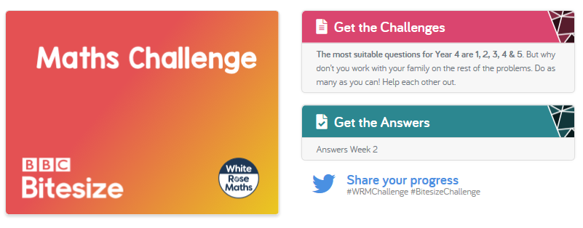
Times Table Focus:  Concentrate on the times tables questions you find most tricky. Do you know the multiplication and the corresponding division facts at speed? Find a way to remember the tricky ones.  Use ‘Hit the button’ on Topmarks to help you  https://www.topmarks.co.uk/maths-games/hit-the-button |  | Key Skills Practice  Doubles and Halves.  Practise recalling your doubling and halving. If you can double 2, can you double 20, or 200? What about using partitioning to half? To halve 68, half 60, then half 8.  Again, practise these skills using ‘Hit the button’ on Topmarks to help you  https://www.topmarks.co.uk/maths-games/hit-the-button

