Science  Choose 5 food packages in your house, look at the labels to find out how much carbohydrates they contain per 100g and sort them from most to least.  Can you remember why carbohydrates are important? | History  Visit  https://www.bbc.co.uk/bitesize/articles/zr2djhv  to learn all about Stonehenge.  Read the information, watch the videos and use the activities to find out all about Stonehenge and how it was built.  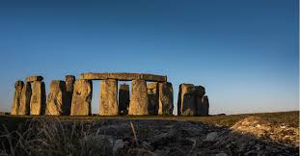 | Geography  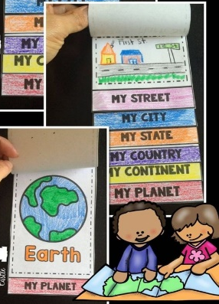  Create a flap book starting with you then zoom out to your street, village, county, country, continent, planet. Draw pictures to go with each step.
Extended Writing  Choose a traditional tale you know really well and re-write it.  Add as much description as you can and try to include some direct speech.  Use the WAGOLL, Success criteria and help sheet to support you when writing. | MFL  Draw and colour in a picture of anything you like then label the colours you have used in French.  I have added a page at the end showing how to spell the colours in French. | Reading  Try to read at least three times a week. You could read your books from school or ones from home. There is also a comprehension activity set on Purple Mash.  Extra challenge  Read every day  Remember to get an adult to ask you some questions about what you have read. You can find these in your reading diaries.
RE  Visit  https://www.bbc.co.uk/bitesize/topics/ztkxpv4/articles/zvfnkmn  to learn about Christianity. After you have watched the video, read the information and complete the activity. Have a go at the quiz and see how many answers you can get right. | PSHE  Make a list of 5 positive things that you and your friends could do to improve the school environment. Draw around your hand and write your ideas up each finger.  Examples- Putting rubbish in the bin, holding the door, cheering someone up who is sad etc. | Computing  Go on to Purple Mash and complete the ‘Magician’ coding challenge set. Watch the videos carefully to find out what to do. You will need to include timers and use the show/ hide blocks.  If you get stuck click on the question mark for a hint.

WAGOLL (What A Good One Looks Like)
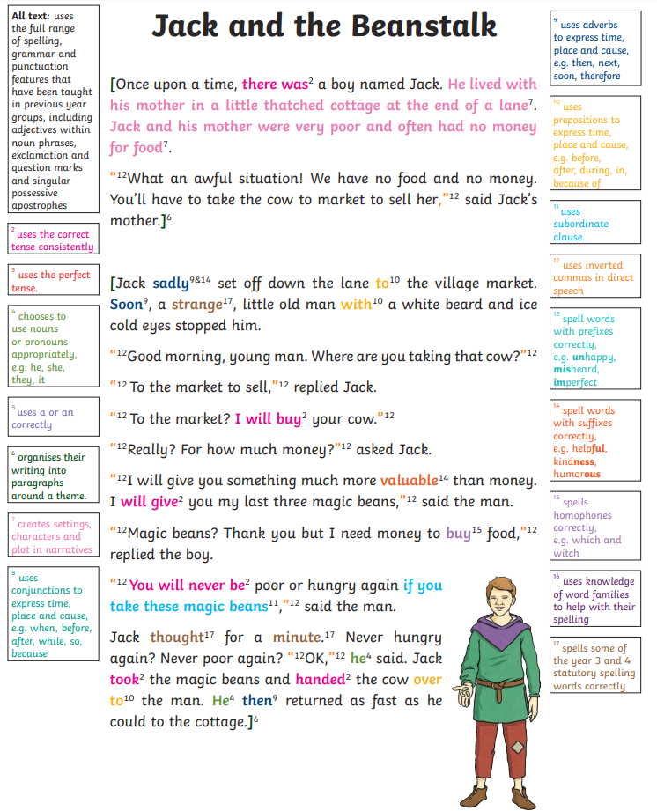

Story Writing Success Criteria - Gold | Self
Have I used accurate speech punctuation with new speaker new line?
Have I used expanded noun phrases?
Have I used ambitious vocabulary?
Have I used a range of conjunctions?
Have I varied my sentence starters?
Have I used accurate punctuation including commas?
Have I used paragraphs?
Have I included adverbs and prepositions?

Story Writing Success Criteria - Silver | Self
Have I used accurate speech punctuation?
Have I used ambitious vocabulary?
Have I used a range of conjunctions?
Have I varied my sentence starters?
Have I used accurate punctuation including commas?
Have I used expanded noun phrases?
Have I used paragraphs?
Have I included adverbs and prepositions?

Story Writing Success Criteria - Bronze | Self
Have I used conjunctions?
Have I tried to include direct speech?
Have I used adjectives for description?
Have I varied my sentence openers?
Have I used accurate sentence punctuation?
Have I re-read my sentences to check they make sense?

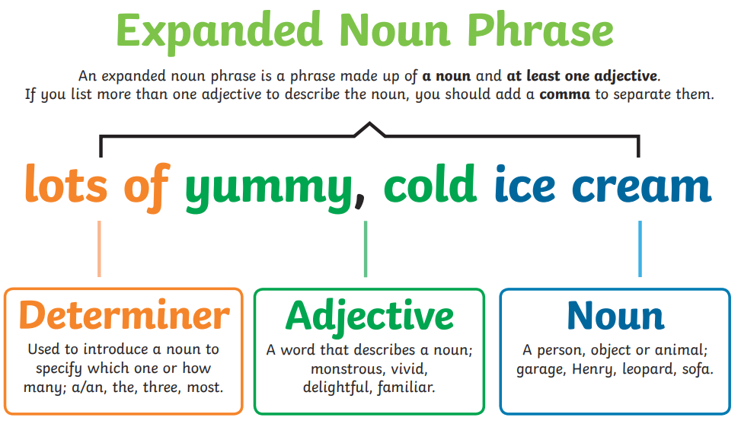
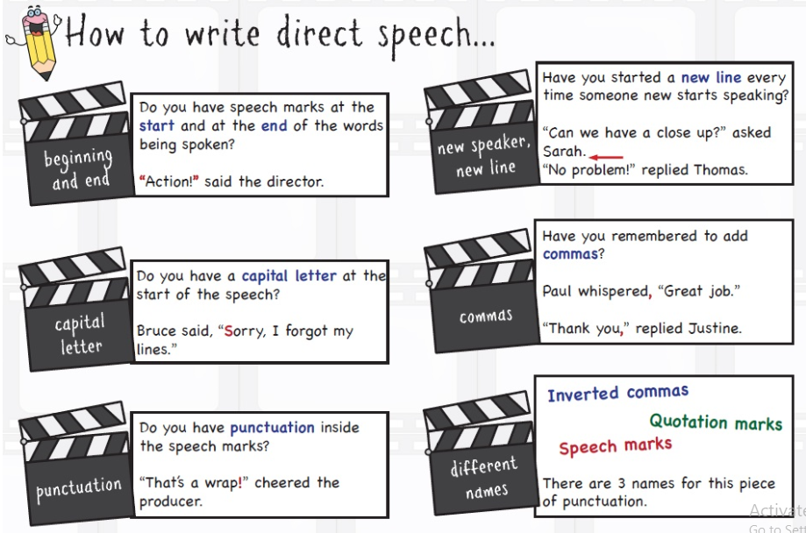
Help sheet

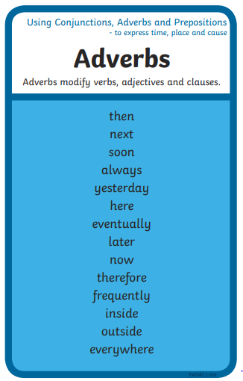
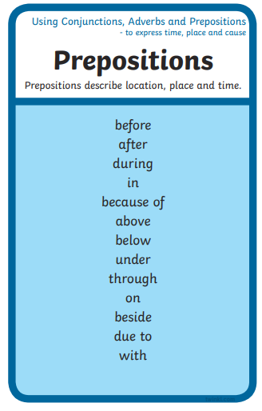

Co-ordinating conjunctions
For, and , nor, but, or, yet, so

Subordinating conjunctions
If, since, as , when, although, while, after, before, until, because
Remember subordinating conjunctions can also be used at the beginning of a sentence.

Colours in French
