Science  Watch this video to recap on your Key Stage 1 learning about Herbivores, Omnivores and Carnivores.  https://www.bbc.co.uk/bitesize/topics/z6882hv/articles/z96vb9q  Now either use the diagram below to complete or log onto Purple Mash and complete the activity about different animal’s diets. | Science/English  In your mouth, you have different types of teeth. Use the link to find out about the different teeth types and the jobs that they do.  https://www.bbc.co.uk/bitesize/topics/z27kng8/articles/zsp76yc  Then create an information poster about the names of the teeth and the jobs they do. You can complete it on paper, or I have set it as a 2do on Purple Mash. | Topic  Learn about Pitz that the Mayans used to play  https://www.bbc.co.uk/bitesize/topics/zq6svcw/articles/zbqyy4j or have a look on Purple Mash to learn about Pok a Toc. Write your own set of instructions for others to follow, in order to play one of the games, or compare it to football.  Maybe you could have a go of playing a Mayan game with members of your family!
Extended Writing  Spending so much time at home means we have probably had more time to do things we usually wouldn’t have time to do. Think about your favourite activity, hobby or game you have been involved with. You are going to write a set of instructions so I can have a go too. It could be a recipe, a game, a craft activity or something else. Use the help sheets below.  Your title will be – How to………………………….. | MFL  Looking at the multiples of 10, see if you can match the French words from the sheet below.  You could make a matching pairs game to practise your French numbers. Play with a family member and see if you can beat them! | Reading  It is really important that you keep up with regular reading, at LEAST 3 times per week. Hopefully, you have been reading lots of your own books. This task is for you to read three times per week. Why not read ‘Time Freeze’ on Purple Mash and complete the activities that support it?
RE  There have been lots of celebrations missed because of our time in lockdown, including birthdays, weddings and christenings. Think of someone you know who has missed a special celebration. Make a card for them, which you will be able to give to them when you see them again. Think about the picture/image on the front and also what message you will put inside. | PSHE  It has been quite a long time now since we have seen each other. How do you think you have changed in this time? Have you grown? Is your hair style different? Do you get on better with your brothers and sisters? Are you helping around the house more? Have you learned a new skill? Have you found a new hobby? Complete the worksheet below to compare the differences in yourself since we last saw you. | Art  Although we are in lockdown, nature is thriving. Look out of your window, sit in your garden or maybe go for a short walk to observe nature in bloom. Why not use our beautiful world to create a piece of art on the theme ‘Springtime’.  Ideas could include: observational drawings, leaf and bark rubbings, collage using natural materials, paint or print using flowers or leaves, Have a look at work created by Andy Goldsworthy too!

Science
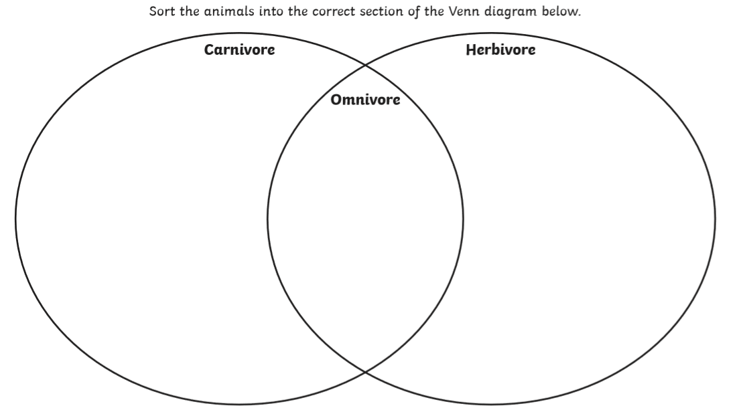
Science
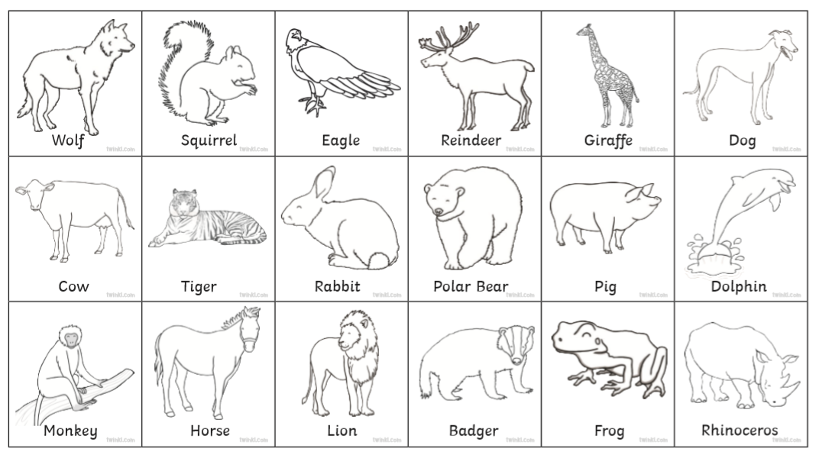

French/MFL

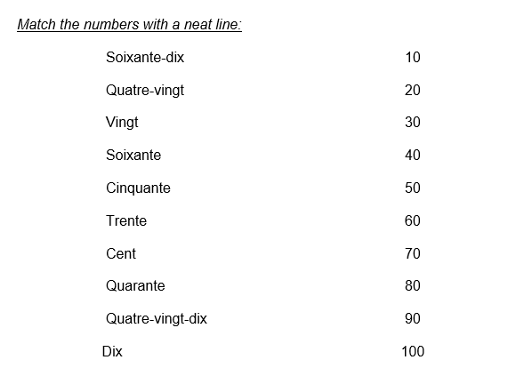

PSHE
How I’ve changed:
Before Lockdown | Now

Art Ideas
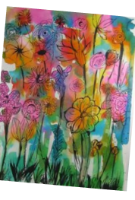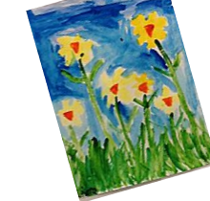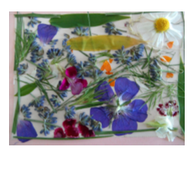

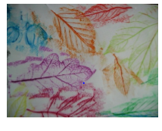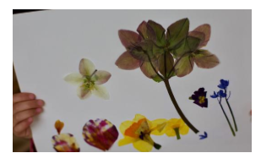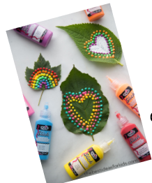

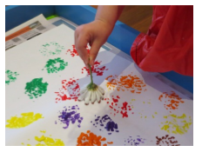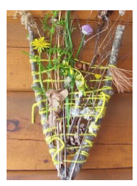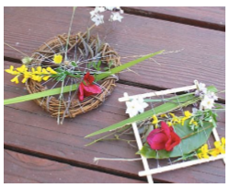

Extended Writing – Instructions - What a good one looks like

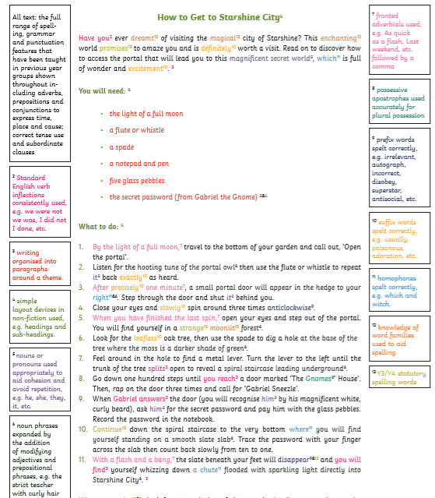

Extended Writing – Success Criteria
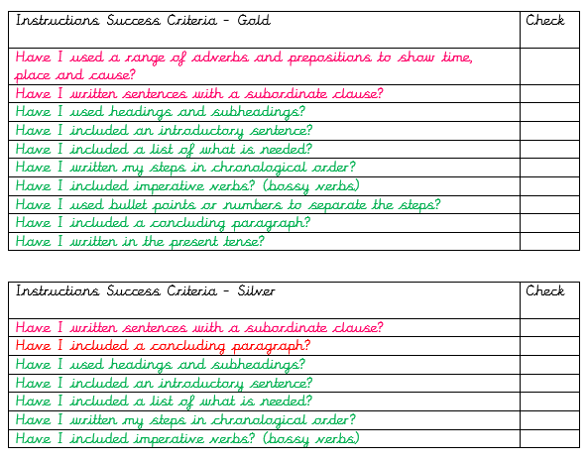
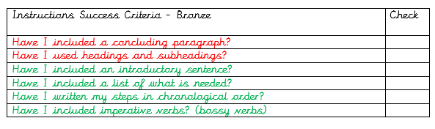

Writing help sheet
