exaggerate | pronunciation | privilege | restaurant | sacrifice
twelfth | opportunity | nuisance | hindrance | harass
existence | embarrass | principal | stationary | interrupt
prophet | licence | compliment | frequently | accompany
available | bruise | committee | conscience | equipped
re-enter | dependable | incredible | infectious | confidential
thorough | thistle | although | nought | deceive
Solemn | ceiling | transferring | hesitancy | fictitious
applicable | devise | vehicle | correspond | language
profit | weary | principle | dessert | stationery
mischievous | allowed | loch | caffeine | seize
provincial | commercial | distinguish | descent | specifically
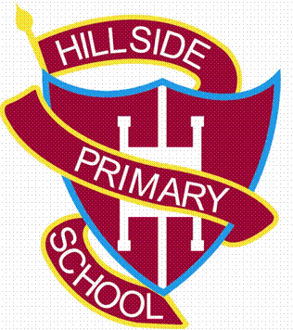
Year 6 Spelling List

