answer | enough | recent | arrive | experience
experiment | mention | surprise | straight | special
eighth | Earth | material | length | question
learn | natural | favourite | build | breath
February | notice | naughty | strength | group
guard | heard | height | position | popular
although | therefore | imagine | increase | potatoes
pressure | probably | promise | difficult | different
interest | consider | circle | fruit | therefore
busy | business | often | woman | describe
attention | intention | sure | parents | half
scene | reign | who’s | seen | rain
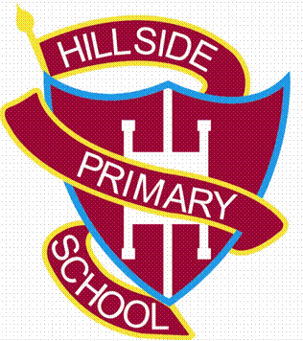
Year 3 Spelling List

