badge | bridge | age | village | energy
city | fancy | knock | knee | gnaw
write | wrote | table | apple | middle
camel | tinsel | squirrel | capital | animal
pencil | nostril | July | reply | try
tries | babies | carries | copied | copier
copying | cried | crying | hiking | hiked
hiker | nicer | nicest | shiny | replies
door | because | children | who | Christmas
humming | hummed | dropping | dropped | all
ball | call | walk | talk | always
brother | mother | Monday | chimney | monkey
wander | quantity | squash | word | work
warm | towards | television | treasure | usual
enjoyment | sadness | playful | plainness | happiness
happily | station | fiction | national | there
they’re | their | night | hear | knight
class | again | money | beautiful | father
can’t | didn’t | hasn’t | couldn’t | I’ll
it’s | Megan’s | David’s | blue | warm
valley | being | skiing | mixing | argument
can’t | quiet | towards | nothing | quite
climb | whole | clothes | water | improve
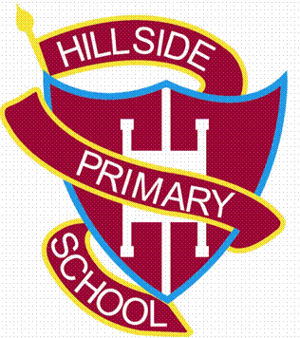
Year 2 Spelling List

