rain | train | play | day | enjoy
annoy | made | take | these | theme
five | time | home | woke | June
tune | car | park | start | tree
green | week | dream | each | head
bread | better | winter | sister | girl
bird | first | turn | church | Thursday
food | pool | zoo | book | took
the | a | do | to | said
boat | road | coach | toe | goes
out | about | now | brown | town
snow | blow | show | rescue | Tuesday
new | flew | threw | lie | cried
chief | field | light | bright | short
horse | morning | shore | more | saw
yawn | August | dinosaur | hair | chair
dear | hear | wear | dare | share
you | your | they | come | here
off | well | notch | have | give
rocks | catches | buzzing | buzzer | buzzed
fresher | freshest | family | dolphin | elephant
unhappy | sketch | playground | bedroom | undo
friend | school | house | says | love
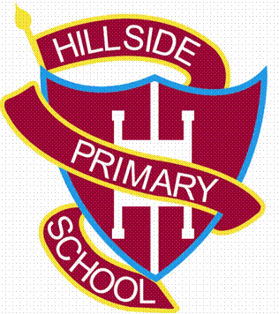
Year 1 Spelling List

